

Loan Repayment Prediction

Vijay Nagaraj Karigowdara

Sai Santosh Kumar Ganti

Table of Contents

1 Introduction 2

2 Business Understanding 2

3 Description of Dataset 2

3.1 Data Description 2

3.2 Source of Data 5

3.3 Goal 5

3.4 Clubbing of Historical Data in JMP Pro 5

3.5 Creating the Class Attribute 5

3.6 Data Loading 6

3.7 Data Analysis 7

3.8 Data Cleaning 8

3.9 Feature transformation 13

3.10 Handling Class Imbalance 14

3.11 Data Loading into Weka 16

3.12 Handling Missing Data 17

4 Attribute Selection and Model Building 18

4.1 Gain Ratio Attribute Evaluation 19

4.2 OneR Attribute Evaluation 19

4.3 Correlation Attribute Evaluation 20

4.4 RelieF Attribute Evaluation 20

4.5 SymmetricUncert Attribute Evaluation 21

4.6 Info Gain Attribute Evaluation 21

5 Classification 22

5.1 Naïve Bayes Algorithm 22

5.2 J48 Algorithm 26

5.3 Random Forest Algorithm 30

5.4 Simple Logistic Algorithm 34

6 Results 38

7 Conclusions 38

8 Work Distribution 39

9 Learnings 39

10 References 40

# Introduction

Classification is one of the most important aspect in Data Mining, trying to predict to which class every observation of the dataset must be placed by constructing a model based on some predictor attributes. We took data from Lending club USA and to do that we will use JMP for data cleaning and preprocessing and Weka for attribute selection and model building.

# Business Understanding

Lending Club is a US peer-to-peer lending company, headquartered in San Francisco, California. It was the first peer-to-peer lender to register its offerings as securities with the Securities and Exchange Commission (SEC), and to offer loan trading on a secondary market. Lending Club operates an online lending platform that enables borrowers to obtain a loan, and investors to purchase notes backed by payments made on loans. Lending Club is the world's largest peer-to-peer lending platform.

Lending Club enables borrowers to create unsecured personal loans between $1,000 and $40,000. The standard loan period is three years. Investors can search and browse the loan listings on Lending Club website and select loans that they want to invest in based on the information supplied about the borrower, amount of loan, loan grade, and loan purpose. Investors make money from interest. Lending Club makes money by charging borrowers an origination fee and investors a service fee.

# Description of Dataset

**Note**: **Please find below google drive link for all dataset, JMP files as these files are huge in size and couldn’t be uploaded in blackboard.**

<https://drive.google.com/file/d/1y-ktw1A0hIc4Nes2mLrMHAC7NVUAXmC4/view?ts=5c9bf23a>

In Blackboard, we have uploaded sampled JMP file having 20,000 rows, *BalancedSampleLoanPredection_20k.csv* (converted from JMP for loading in weka) file and weka file (*LoanPredection.arff*) used to select attributes and build model.

## Data Description

Loan data from year 2007 to 2018 downloaded from Lending Club USA. The files have been renamed according to the year e.g.: LoanStats_2007_2011.csv LoanStats_20012_2013.csv …. LoanStats_2018Q4.csv.

There are total 145 columns and 2,260,705 rows when files are put together. For detailed description of all 145 columns, please refer the attached Data Dictionary file (LCDataDictionary.xlsx). When a single file with 40k rows was loaded into Weka, there was error in loading as the data was messy. So, in our project we did all the data cleaning tasks in JMP and later used Weka for attribute selection and model building. Below is the column description of 25 columns after preprocessing the data.

|  |  |  |
| --- | --- | --- |
|  | Attribute | Description |
|  | acc_open_past_24mths | Number of trades opened in past 24 months. |
|  | annual_inc | Self-reported annual income provided by the borrower during registration. |
|  | avg_cur_bal | Average current balance of all the accounts. |
|  | bc_util | Ratio of total current balance to high credit/credit limit for all bankcard accounts. |
|  | delinq_2yrs | Number of 30+ days past-due incidences of delinquency in the borrower’s credit file for the past 2 years. |
|  | dti | debt-to-income ratio calculated using the borrower’s total monthly debt payments on the total debt obligations, excluding mortgage and the requested LC loan, divided by the borrower’s self-reported monthly income. Purpose represents self-reported purpose of loan provided by the borrower during application process. |
|  | emp_length | Borrower’s employment length in years. Possible values are between 0 and 10 where 0 means less than one year and 10 means ten or more years. |
|  | funded_amnt | The total amount committed to that loan at that point in time. |
|  | grade | Variable which belongs to behavioral category. Lending Club categorized borrowers into seven different loan grades from A (best) to G (poor). This grade is assigned by Lending Club employees after the borrower’s credit history is analysed. |
|  | home_ownership | Status provided by the borrower during registration or obtained from the credit report. |
|  | inq_last_6mths | Number of inquiries in past 6 months. |
|  | int_rate | The annual rate on the loan. |
|  | last_pymnt_amnt | Last total payment amount received |
|  | **loan_status** | Class Variable. In the raw dataset has 10 different values (shown later). However, in our model we will use 2 values. We will encode the variables to **Not-Defaulter** which represent *Fully Paid*, while **Defaulter** will represent *Charged Off, Late (31-120 days)*, Default and we will ignore everything else as it is not required. |
|  | mo_sin_old_rev_tl_op | Months since oldest revolving account opened |
|  | mo_sin_rcnt_rev_tl_op | Months since most recent revolving account opened. |
|  | mort_acc | Number of mortgage accounts. |
|  | num_actv_rev_tl | Number of currently active revolving trades. |
|  | open_acc | Number of open credit lines in the borrower’s credit file. |
|  | pub_rec | Number of derogatory public records. |
|  | purpose | A category provided by the borrower for the loan request. |
|  | revol_bal | Total credit revolving balance. |
|  | revol_util | Revolving line utilization rate, or the amount of credit the borrower is using relative to all available revolving credit. |
|  | term | The number of payments on the loan. Values are in months and can be either 36 or 60. |
|  | verification_status | Indicates if income was verified by LendingCLub, not verified, or if the income source was verified. |

## Source of Data

The data collection was done through the following website –

1. <https://www.lendingclub.com/info/download-data.action>

The data was consolidated from 2007 o 2018 and clubbed in JMP pro and converted to csv after data pre-processing.

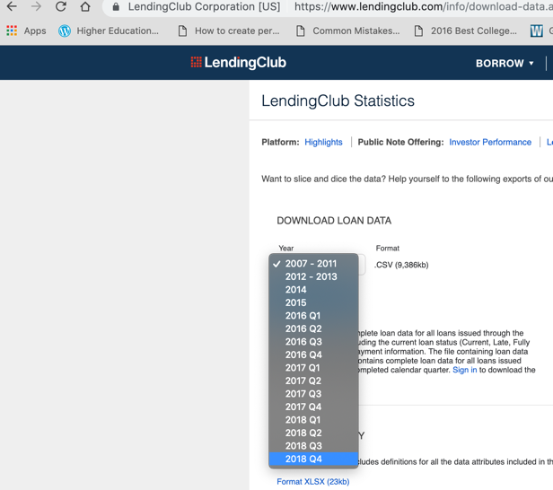

## Goal

People often save their money in the banks which offer security but with lower interest rates. Lending Club operates an online lending platform that enables borrowers to obtain a loan, and investors to purchase notes backed by payments made on loans. It is transforming the banking system to make credit more affordable and investing more rewarding. But this comes with a high risk of borrowers defaulting the loans. Hence there is a need to classify each borrower as defaulter or not using the data collected when the loan has been given.

To classify if the borrower will default the loan using borrower’s finance history. That means, given a set of new predictor variables, we need to predict the target variable as Defaulter or Non-Defaulter. The metric we use to choose the best model is ‘False Negative Rate’. (predictor and target variables explained later).

## Clubbing of Historical Data in JMP Pro

We took data for multiple years data from lending club i.e., from 2007 to 2018 and combined all of them into one dataset in JMP pro and went ahead with cleaning the data.

## Creating the Class Attribute

We took the field “**loan_status**” as the class attribute and we recoded the values and clubbed them into two nominal attributes “Defaulter” and “Not-Defaulter”. We also performed stratified sampling to balance the class attributes.

Note: This is the dataset which would be used for data modeling.

## Data Loading

1. Loan data from year 2007 to 2018 downloaded from Lending Club USA. The files have been renamed according to the year. Example: LoanStats_2007_2011.csv LoanStats_20012_2013.csv to LoanStats_2018Q4.csv.
2. We can observe from the dataset that the column names start from line 2 and data starts from line 3, so we change accordingly.

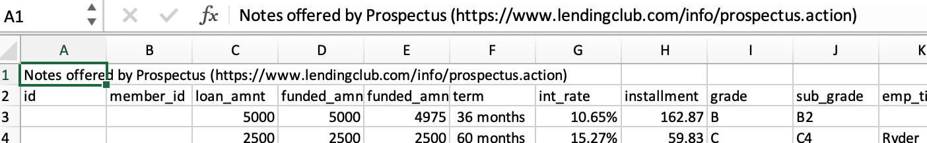

Following these steps, *Open multiple files -> Choose folder containing dataset -> Select extension as *.csv - > Select CSV settings -> First Header Line:2, First Data Line:3.*

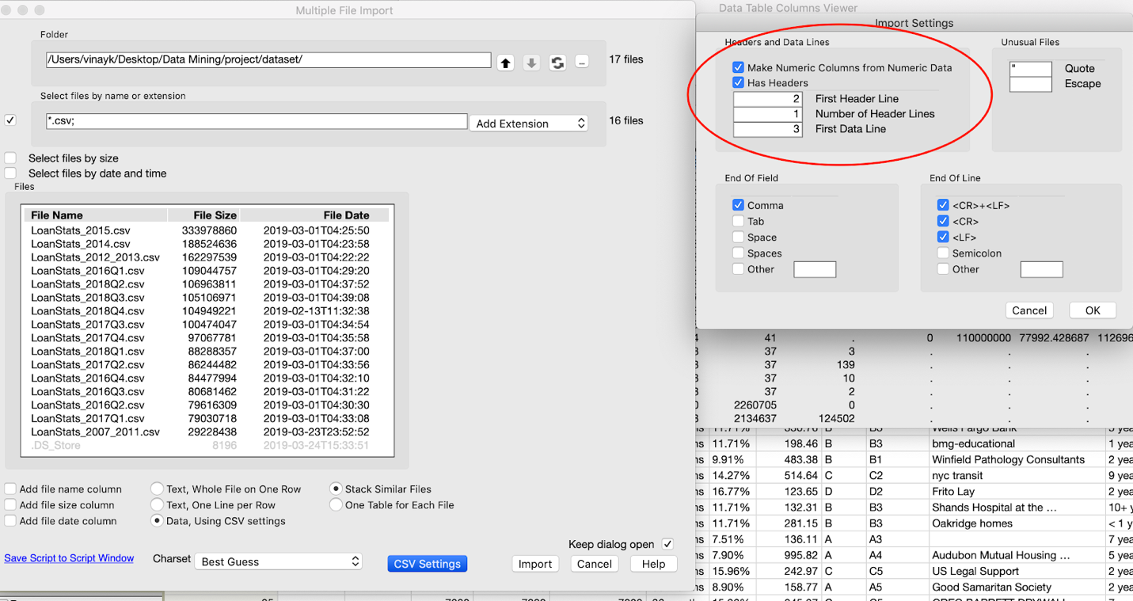

1. After importing the data, we can observe that dataset contains 145 columns and 2,260,705 rows.

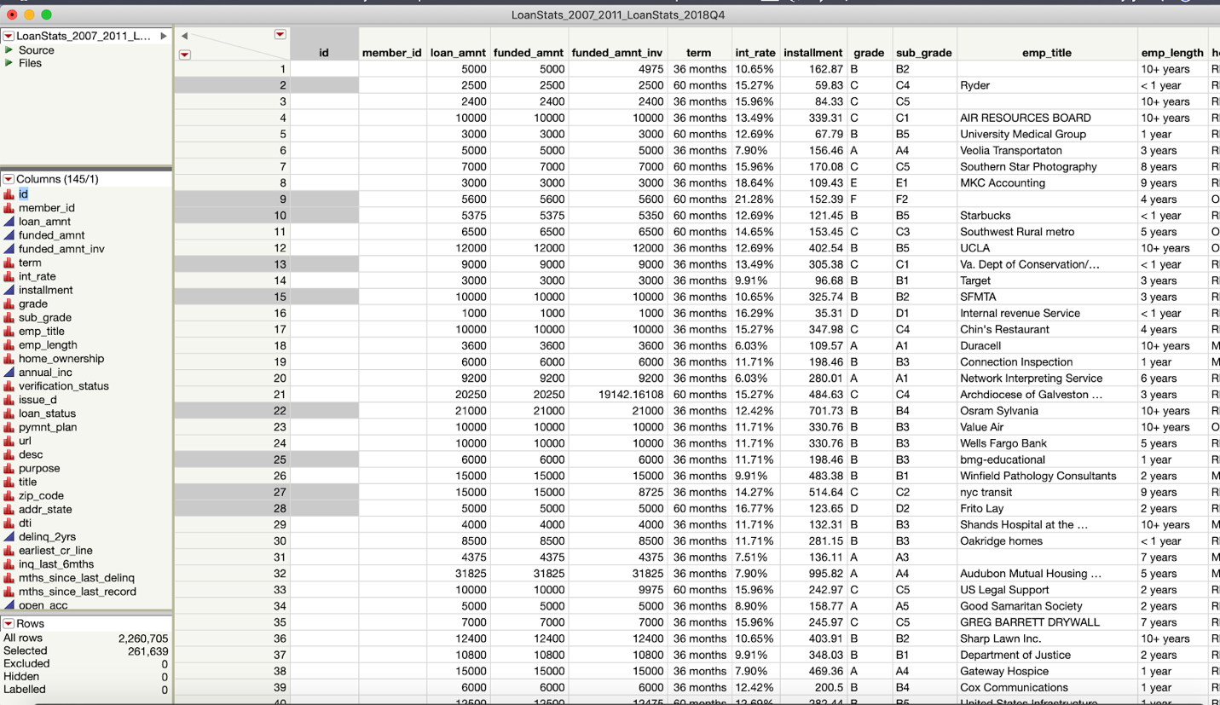

## Data Analysis

In Column Viewer, we can check for missing values, mean, median, mode and quartile range etc. under show summary. PFA (/*JMP_Files/Colums_Viewer.jmp*) for detail view.

*Cols -> Columns Viewer -> Select All Columns -> Click Show Summary*

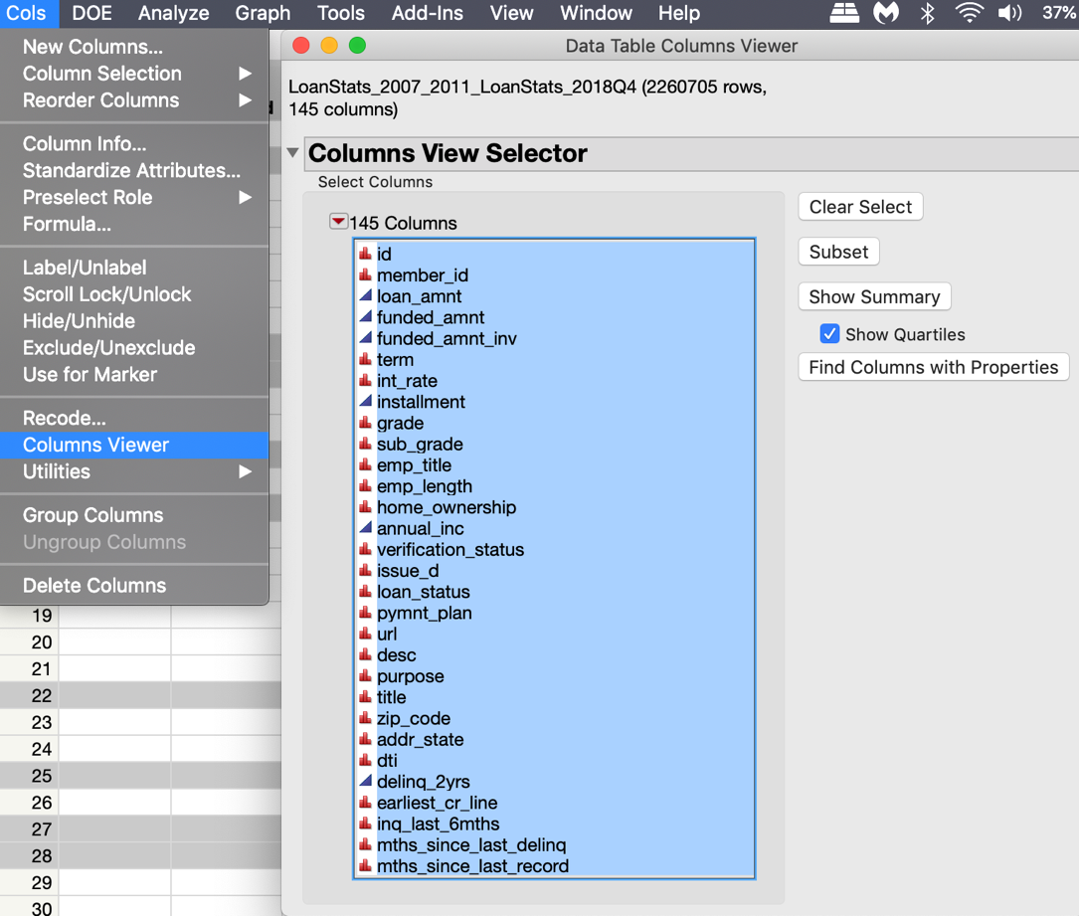

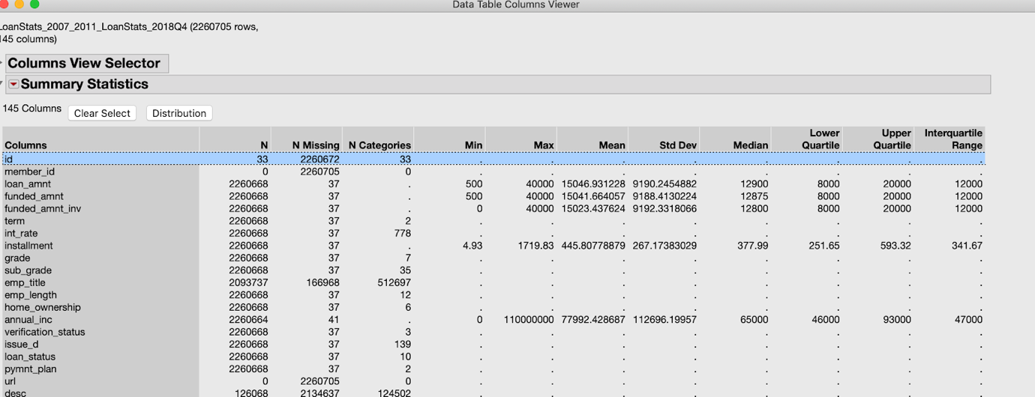

## Data Cleaning

The data set had many discrepancies like missing data, imbalanced data attributes and lots of unnecessary columns. And, Weka doesn’t allow datasets to have such discrepancies. Hence, we decided to do the data preprocessing in JMP pro.

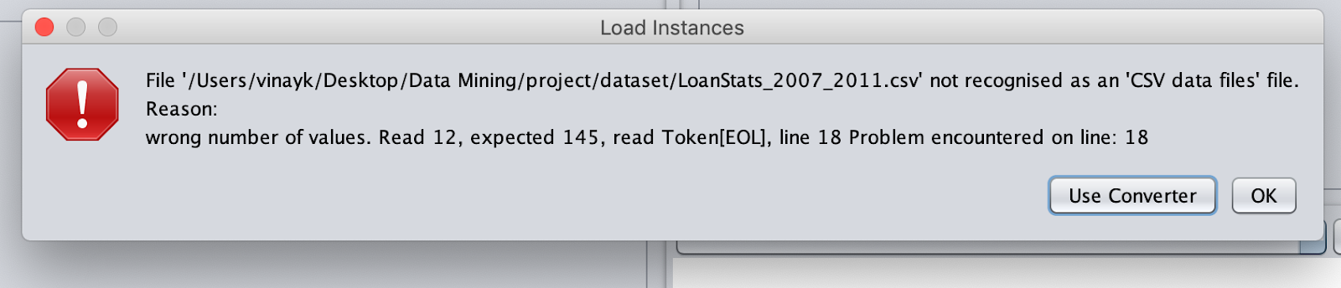

As there were 145 columns, we had to drop lot of irrelevant columns based on below conditions.

1. Remove high percentage of missing values as it is difficult for the model to learn.
2. Removing columns with very low variance. If features have same values, then model won’t learn anything.
3. Examining Pairwise Correlation. If 2 features are highly corelated, then keeping only one will help reduce dimensionality without much loss of information.

### Cleaning data based on Class attribute

We have total of 22,60,705 rows, our class attribute “loan_status” has 10 different values shown below.

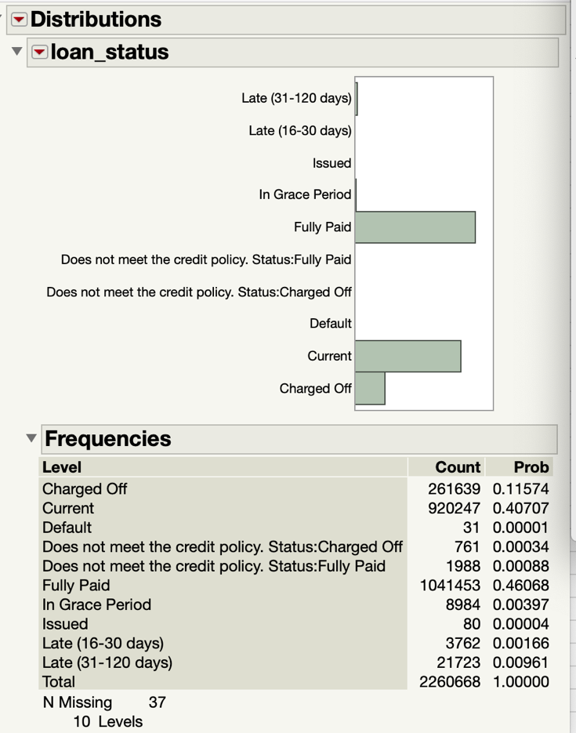

Our goal is to predict weather a person defaults the loan or not, so we will consider *Late (31-120 days), Default, Charged Off* as a **Defaulter** loan and *Fully Paid* as a **Not-Defaulter** and ignore everything else as those are not relevant. We used the recode feature in JMP to convert our class variable into binary form and by replacing the values to 0 or 1. 0 for fully paid and 1 for late/default status. Also, the rest of the status is given -1 value and later be deleted.

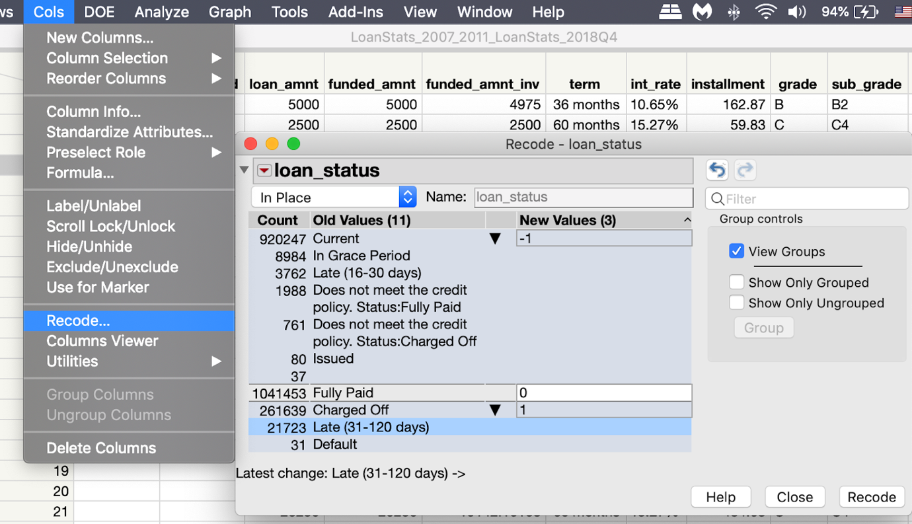

Now we will eliminate all rows with “-1” as the loan status. To do that we have to right click and select all matching rows with “-1” and then proceed to deleting the rows. Previously, the number of rows in the dataset were 22,60,705 and now the rows are 13,24,846.

### Removing Columns with more than 50% data missing

The column viewer gives the details below, we will use this column viewer’s summary feature of JMP to find the missing data in the columns. And after running the column viewer and sorting the columns with N in ascending we get the columns with no data and we have deleted these columns by selecting them and deleting these columns using JMP.

We will get the data from column viewer and sort the columns based on N in ascending order.

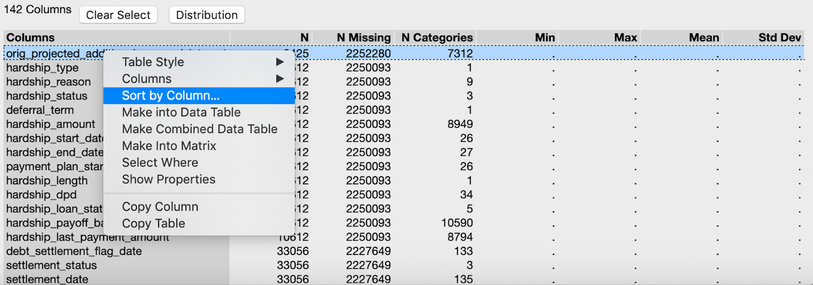

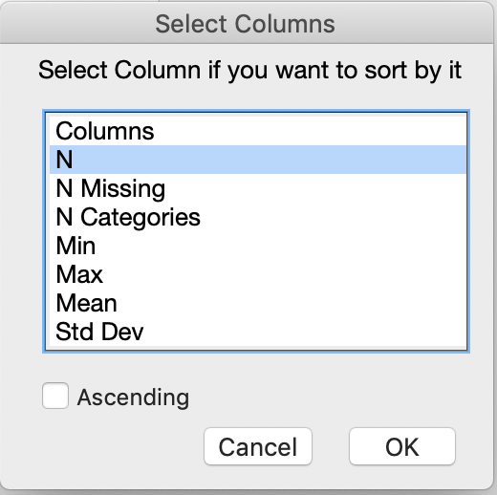

We will now look at columns with a lot of missing data and some useful data to determine if we need these features for our classification.

Out of 145 columns and we have 13,24,846 rows, we will remove columns whose missing data is more than 50%. i.e. data whose missing value of greater than 6,62,423 will be deleted.

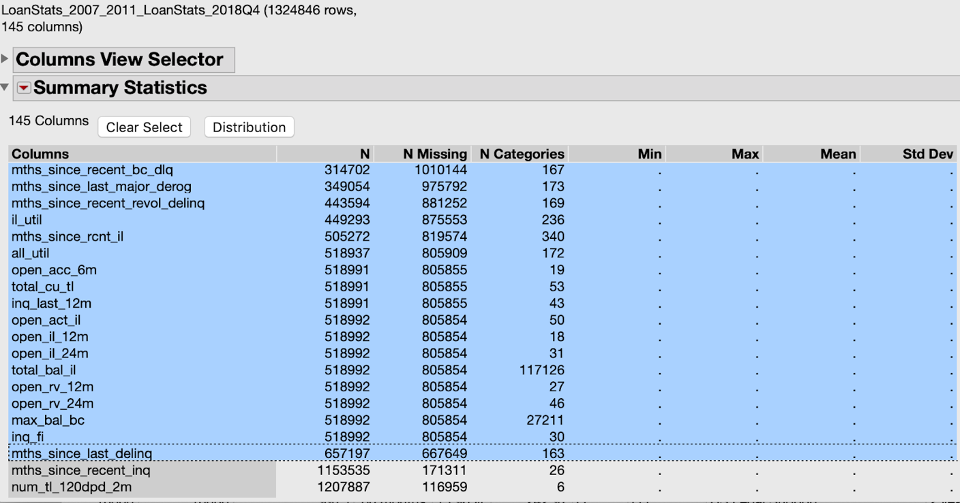

Looking at data dictionary, we can identify and drop irrelevant features. These features are deleted because they aren’t really required for our model.

Also, the columns with date values, zero variances and column values skewed more than 95% are removed. PFA excel file (*/dataset/LoanPredictionsFeatures.xlsx*) for details of all the removed columns.

### Modifying data type of the columns

When we imported the data, the data types for some columns were not properly set and we will now manually update the data types on JMP pro. One advantage of doing this is that we can then get the variance of the columns and proceed with eliminating more columns. The following are the columns for which the data types has been changed from nominal to continuous:

PFA excel file: */dataset /LoanPredictionFeatures.xlsx, sheet name: NominaltoContinuous*

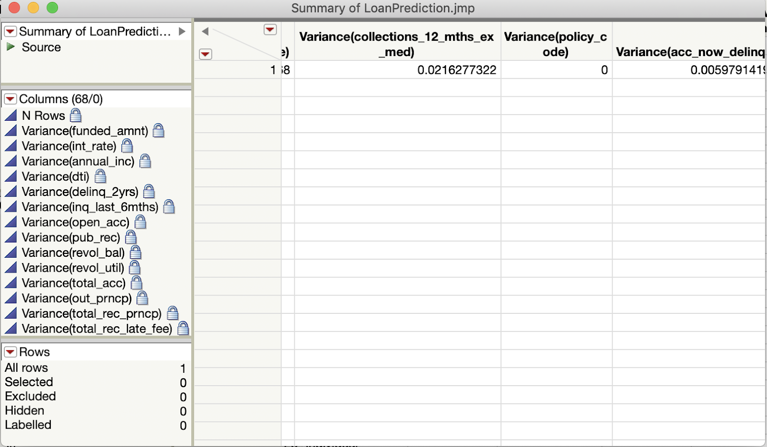

Similarly, we will remove unwanted columns by examining data dictionary (details file explaining about column) and by observing pairwise correlation. These features don’t contribute to the model. PFA excel file as columns list is long.

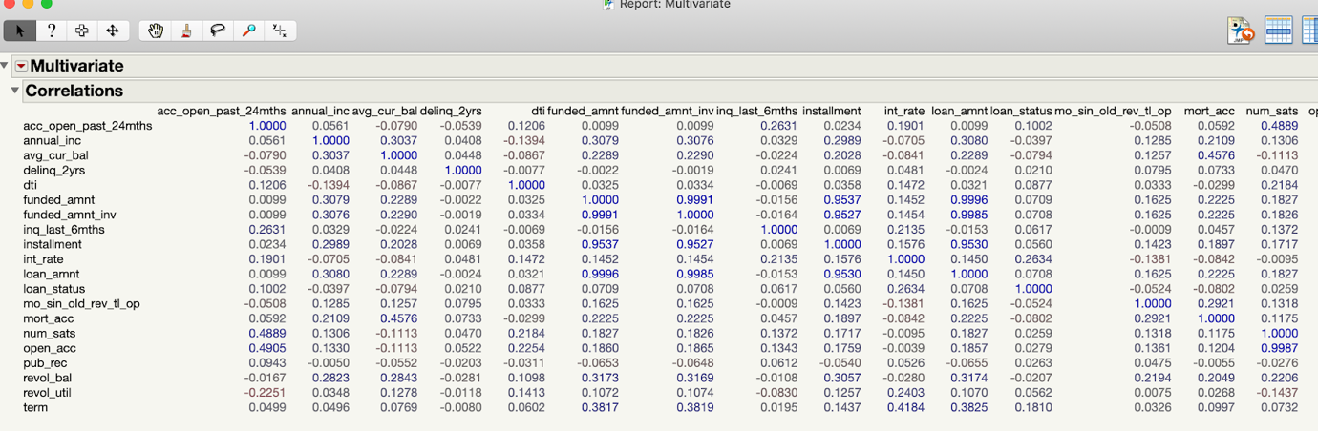

If 2 features are highly correlated, then keeping only one will help reduce dimensionality without much loss of information. We will keep the one that has higher correlation with the target. PFA file /JMP_Files/*Multivariate.jrp* for details view of correlation.

Below are the columns removed based on pairwise correlation.

‘funded_amnt’ instead of ‘funded_amnt_inv’ and ‘loan_amnt’’ and ‘installment’,

‘open_acc’ instead of ’num_sats’.

## Feature transformation

Previously we had transformed features from Nominal to Continuous by examining for data cleaning purpose. Additionally, some columns have to be transformed.

### Emp_length

We will recode to proper format as shown below and change the data type from nominal to continuous numeric.

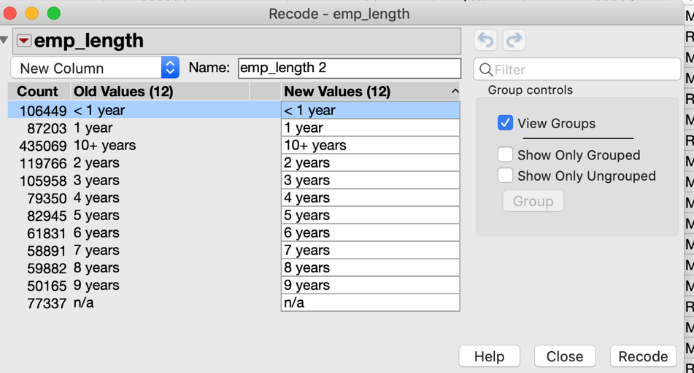

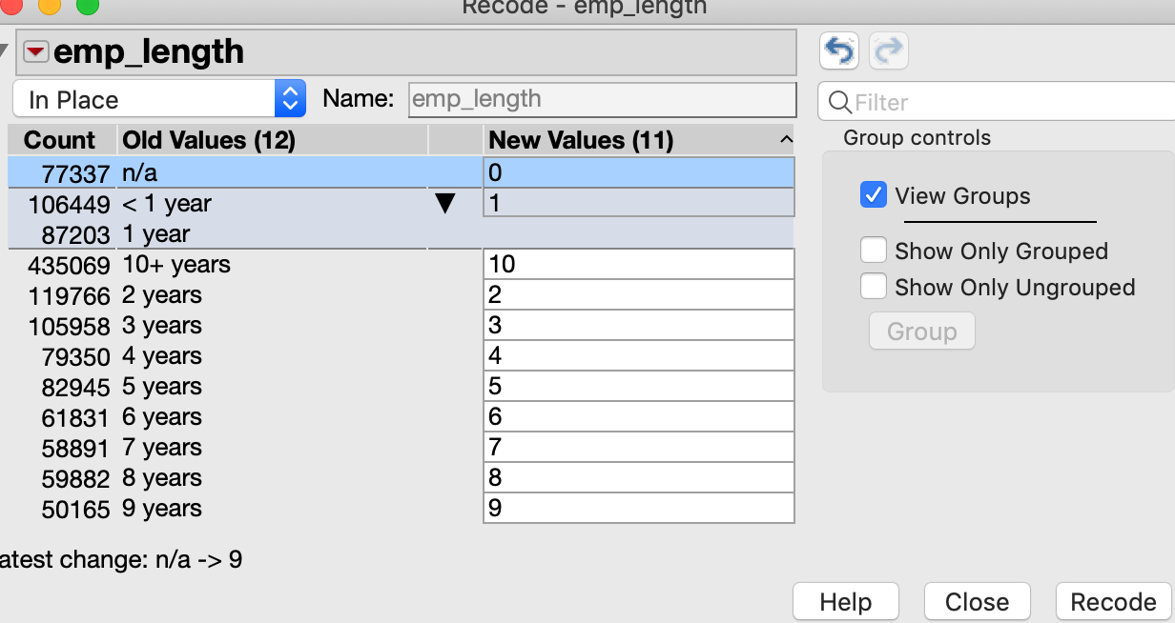

### loan_status

We will make value labels as shown below.

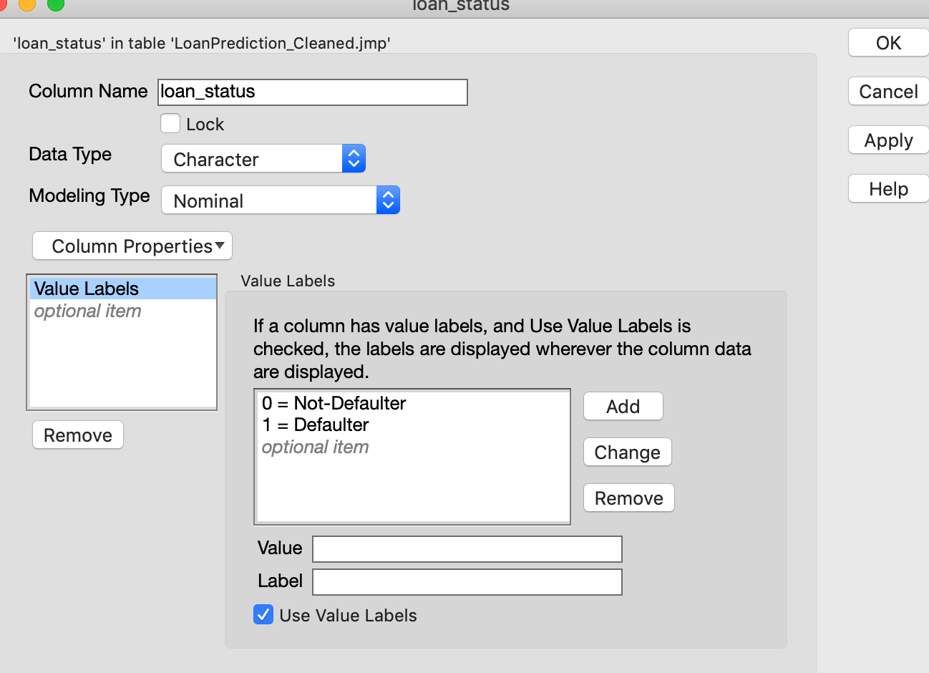

### grade

We will make grade column as ordinal.

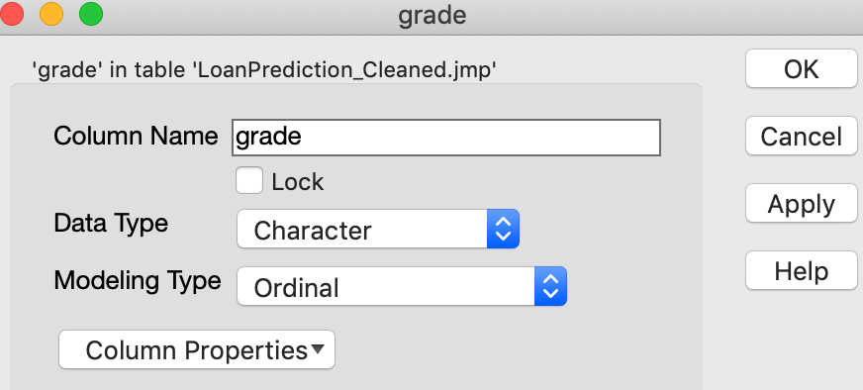

Please find attached */JMP_Files/ LoanPrediction_Cleaned.jmp*. The file contains all the data after pre-processing is done.

## Handling Class Imbalance

From the class attribute, we can observe that there is an imbalance.

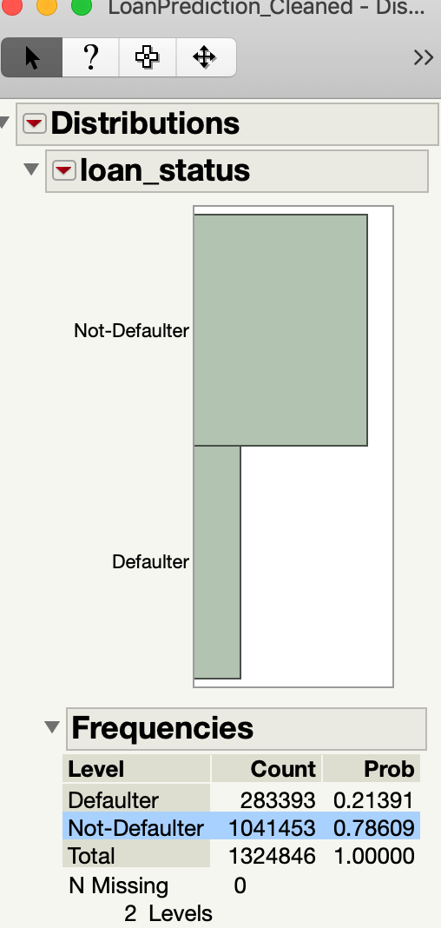

We will remove imbalance by taking the sample based on class variable **loan_status** of the data as shown below

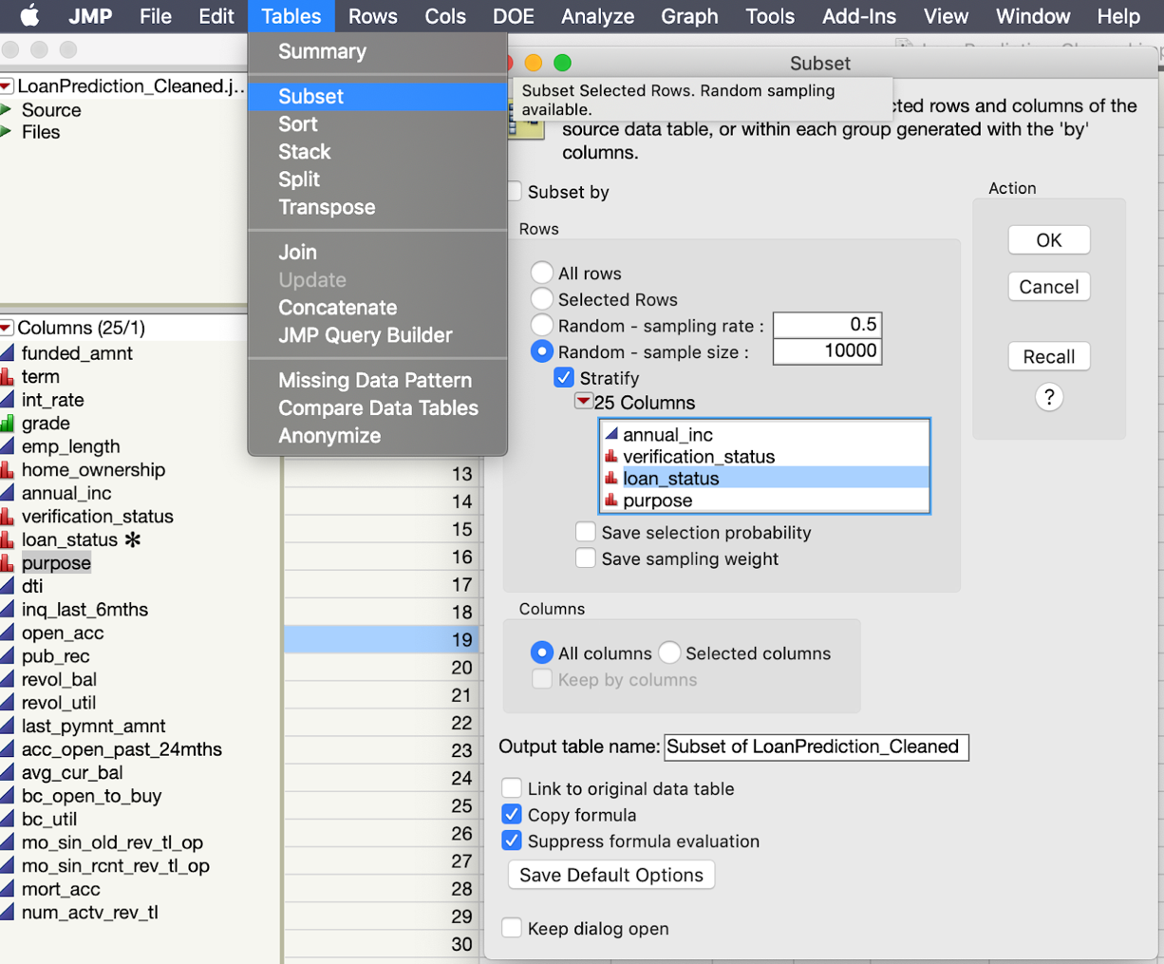

After sampling, we have 20,000 rows with class attribute balanced.

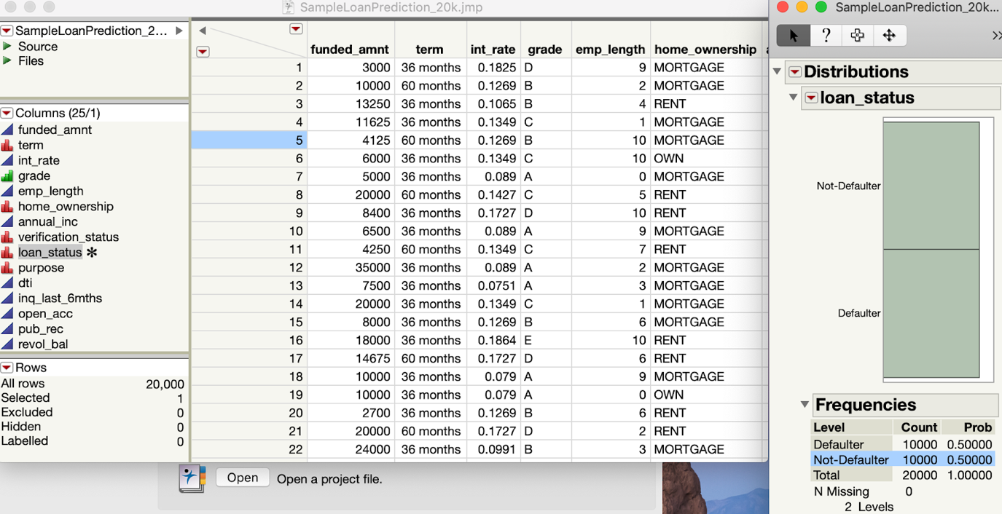

Now, we have the balanced sample data which contains 20,000 rows. Please find attached */JMP_Files/ SampleLoanPrediction_20k.jmp*. The file contains sample of previous data with 20,000 rows. Then we will run the */JMP_Files/JMP_CSV.jsl* script (PFA) to convert the JMP file data to CSV file so that we can build model in Weka.

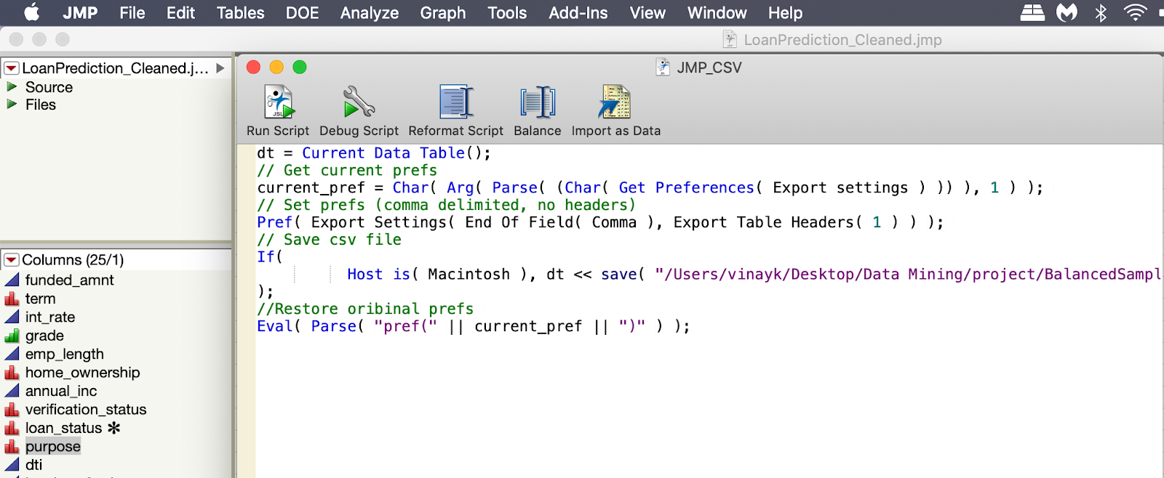

## Data Loading into Weka

The converted CSV file *(/Weka/BalancedSampleLoanPredection_20k.csv*) is loaded into Weka. Then class attribute is chosen as **‘loan_status’**. There are 20,000 instances with class attribute balanced. Then we build different models based on various attribute selection algorithm. PFA */Weka/LoanPredection.arff* file to start selecting attributes and building model.

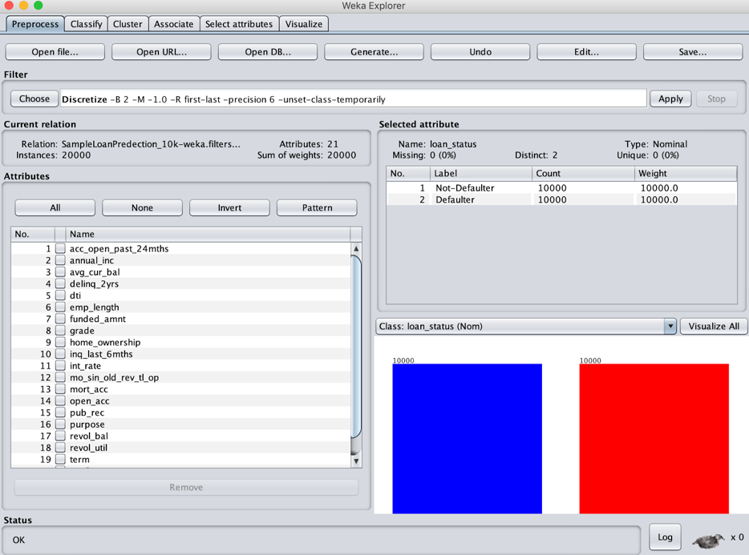

## Handling Missing Data

We observed that three of the columns were having missing values. They are, *“acc_open_past_24mnths”, “mo_since_old_rev_tl_op”, “avg_cur_bal”.* So, we have replaced the missing values using Weka.

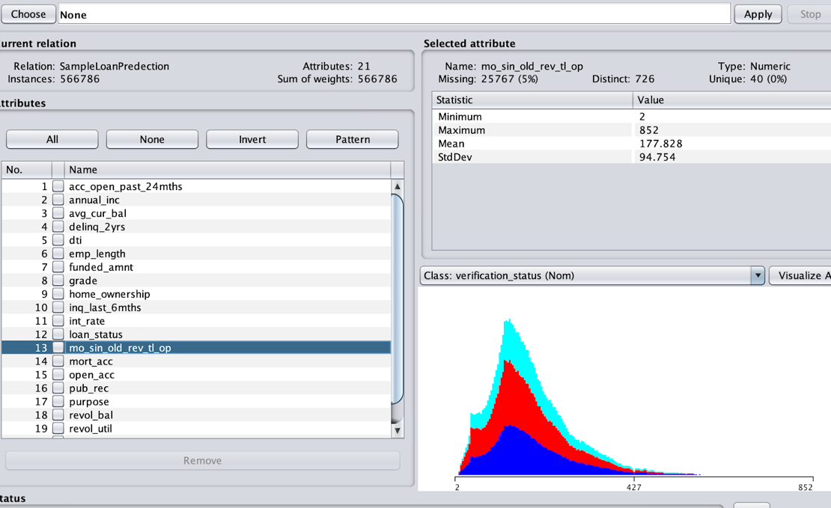

# Attribute Selection and Model Building

Now, the data is ready to be modelled. As there are a lot of dimensions and we are not considering all the attributes so, the dimensions are reduced to build the model. To do so, we have taken 6 selection attribute algorithms into consideration.

These algorithms would give the best set of pairs which would be considered for our model building.

*Note: Building models using ReliefF Attribute Evaluation takes long time (nearly 15-20 mins) as there are 20,000 instances.*

1. Gain Ratio Attribute Evaluation
2. OneR Attribute Evaluation
3. Correlation Attribute Evaluation
4. ReliefF Attribute Evaluation
5. SymmetricUncert Attribute Evaluation
6. InfoGain Attribute Evaluation

## Gain Ratio Attribute Evaluation

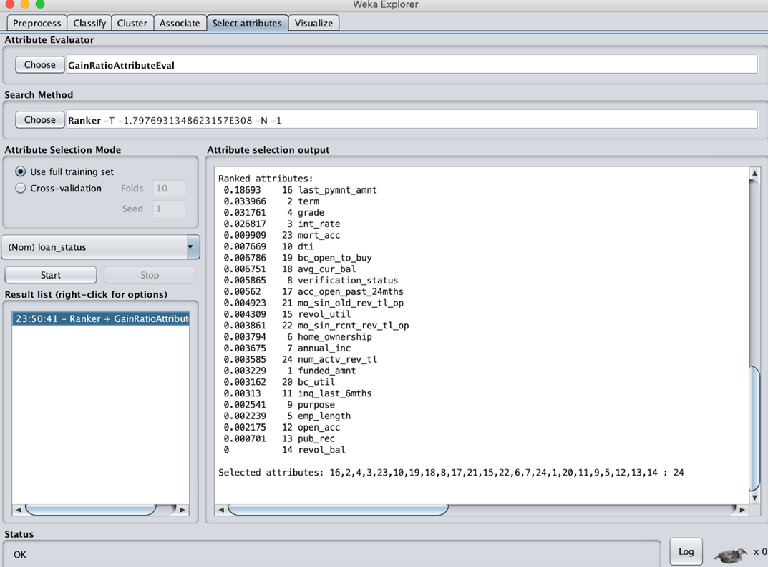

## OneR Attribute Evaluation

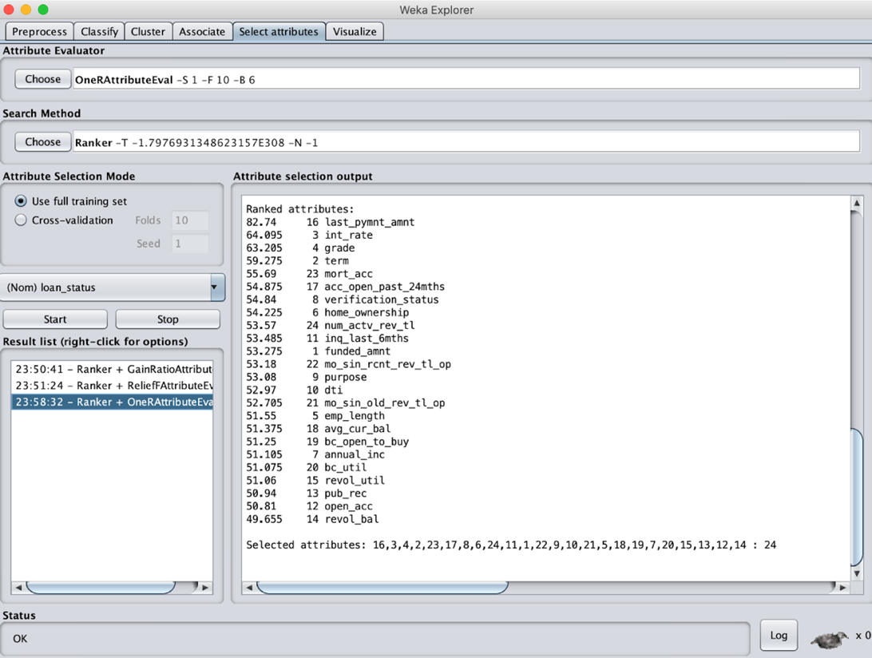

## Correlation Attribute Evaluation

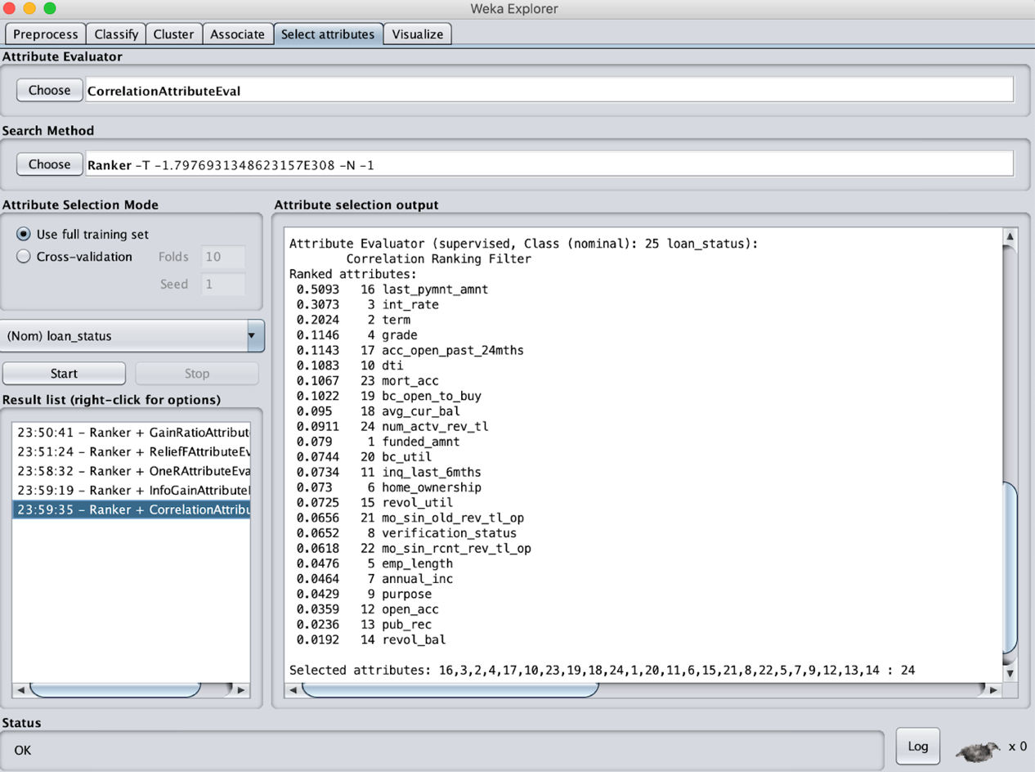

## RelieF Attribute Evaluation

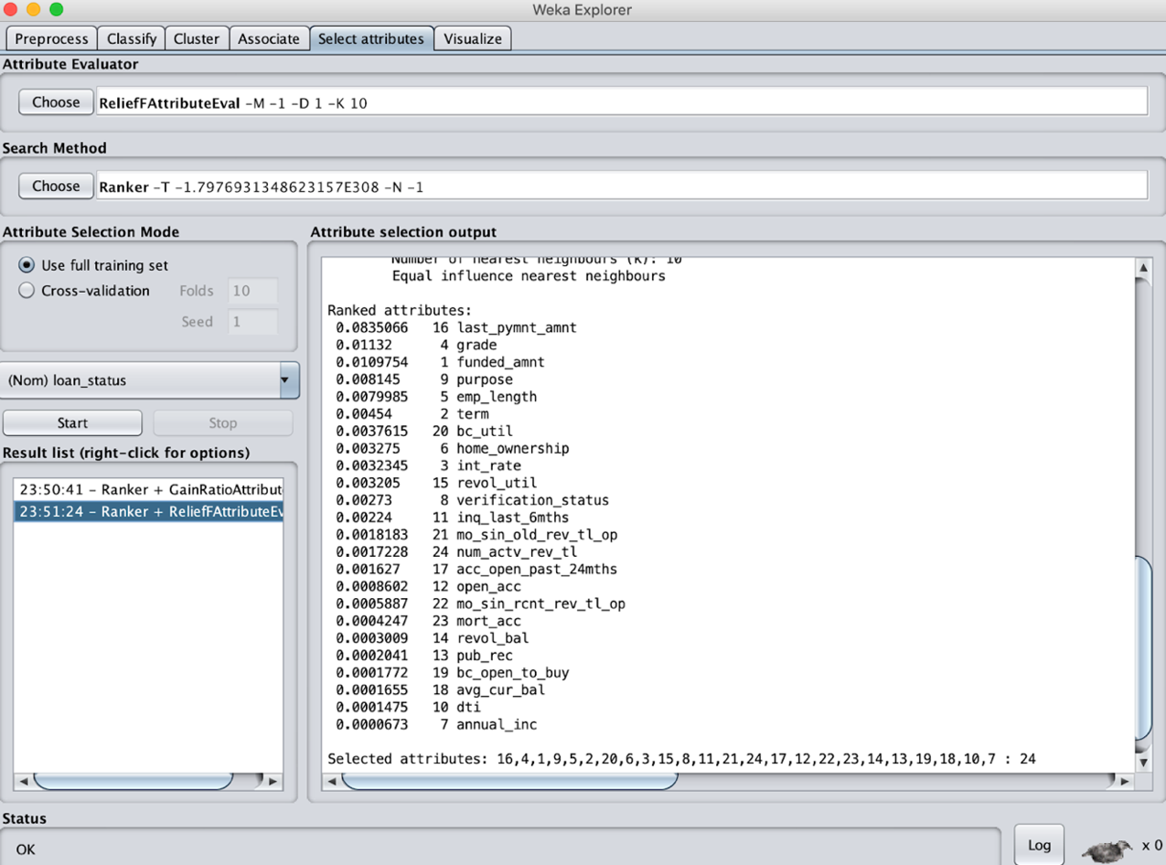

## SymmetricUncert Attribute Evaluation

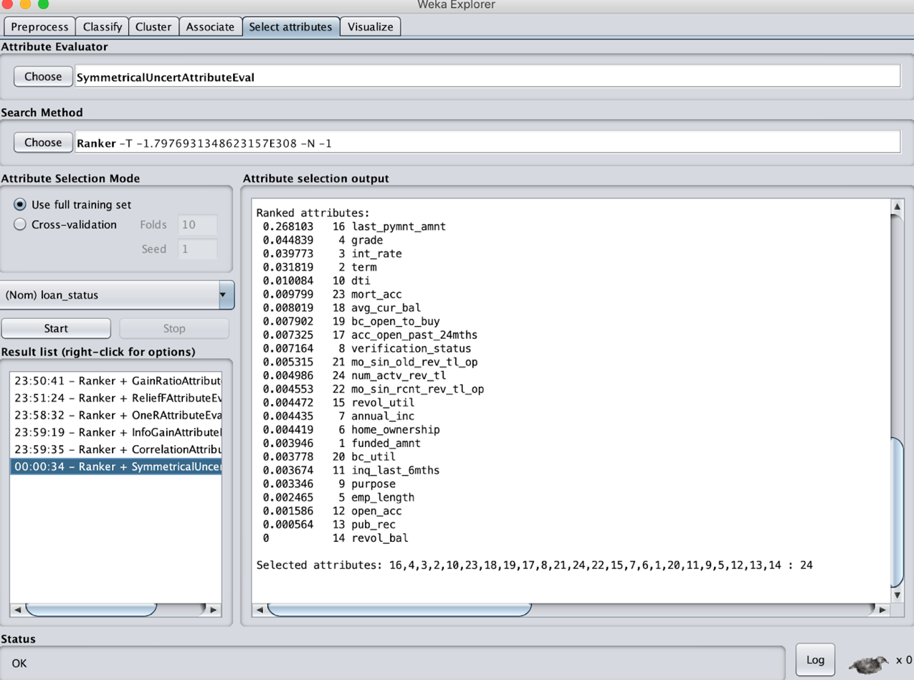

## Info Gain Attribute Evaluation

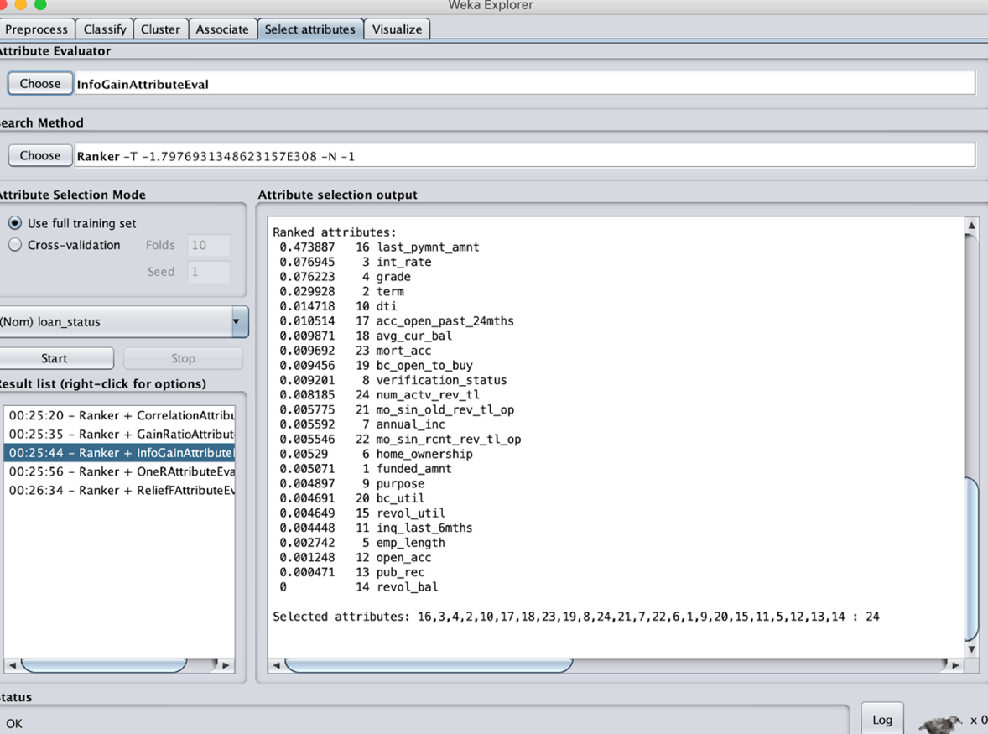

We will use only the Top 10 for dimension reduction. Using ranker method.

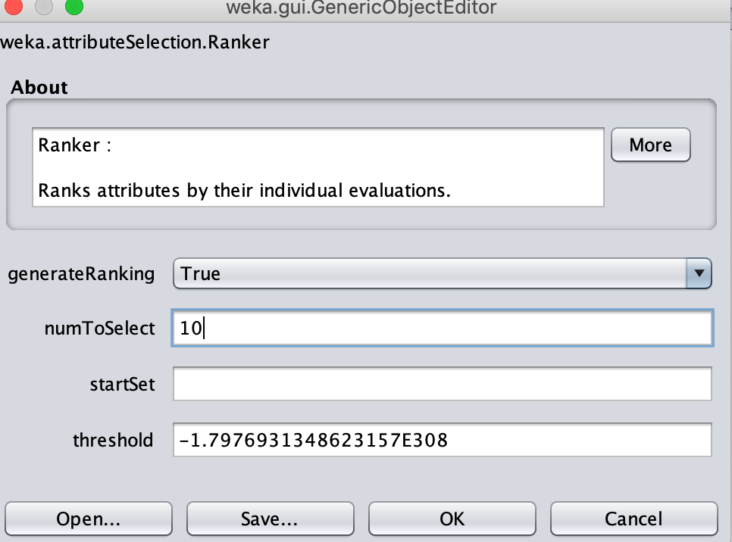

# Classification

Classification is a data mining function that assigns items in a collection to target categories or classes. The goal of classification is to accurately predict the target class for each case in the data. For example, a classification model could be used to identify loan applicants as low, medium, or high credit risks. We have used K-Fold cross validation in all the below classification algorithm.

## Naïve Bayes Algorithm

Naive Bayes is a simple, yet effective and commonly-used, machine learning classifier. It is a probabilistic classifier that makes classifications using the Maximum A Posteriori decision rule in a Bayesian setting. It can also be represented using a very simple Bayesian network. Naive Bayes classifiers have been especially popular for text classification and are a traditional solution for classification problems.

The goal of any probabilistic classifier is, with features x_0 through x_n and classes c_0 through c_k, to determine the probability of the features occurring in each class, and to return the most likely class. Therefore, for each class, we want to be able to calculate P (c_i | x_0, …, x_n).

In order to do this, we use Bayes rule. Recall that Bayes rule is the following:

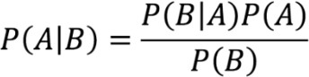

In this case, A and B represent class Defaulter or Not-Defaulter for the loan borrowers.

### Using Gain Ratio Attribute Evaluation

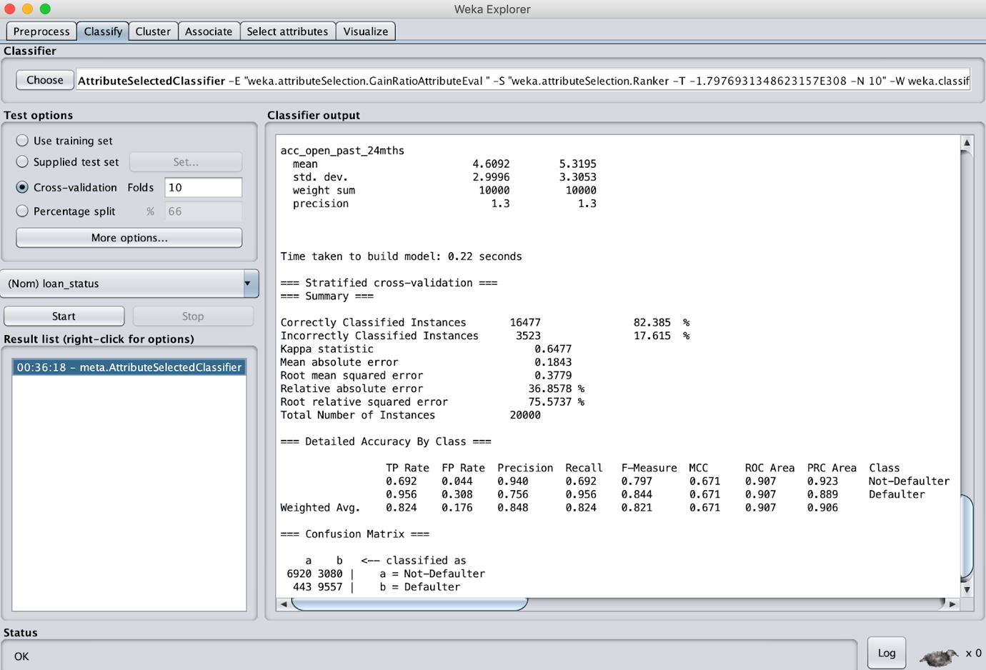

### Using Correlation Attribute Evaluation

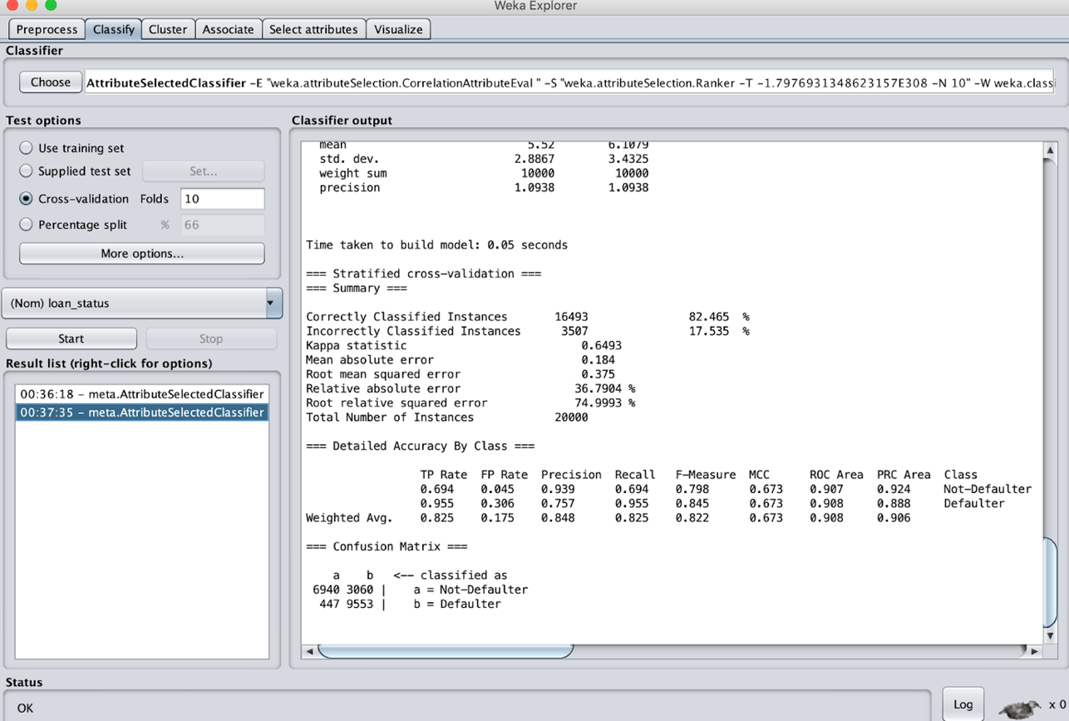

### Using InfoGain Attribute Evaluation

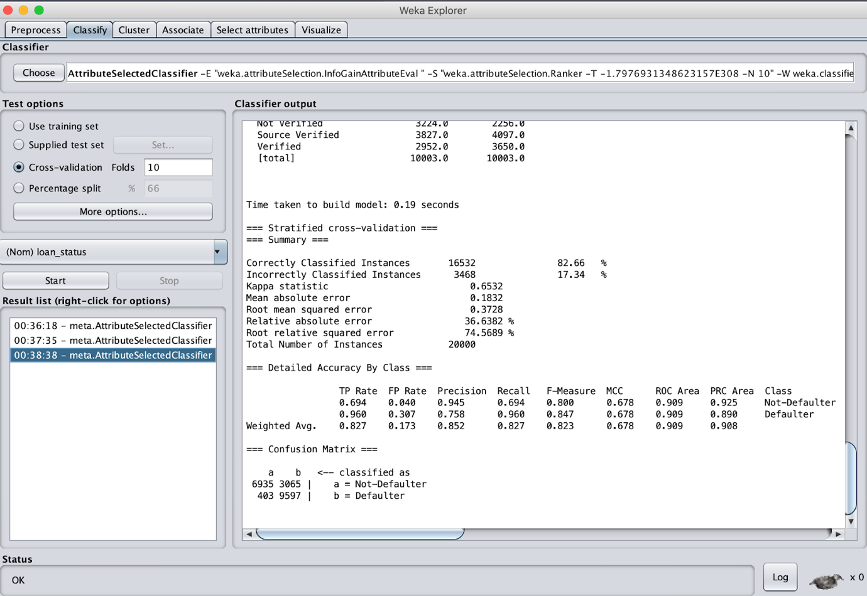

### Using OneR Attribute Evaluation

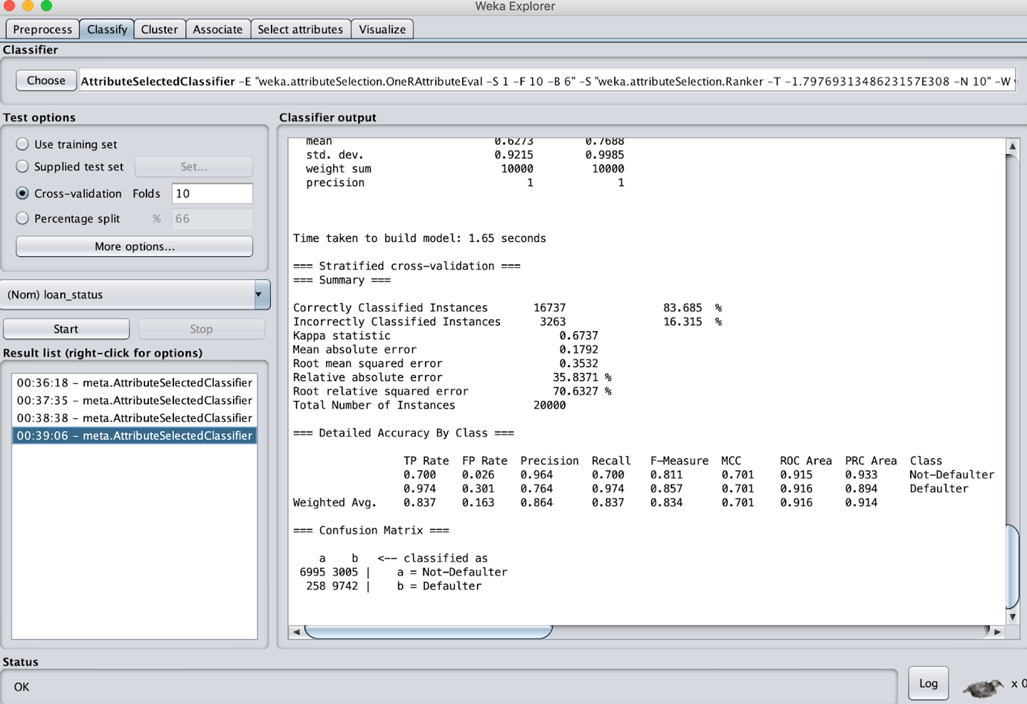

### Using RelieF Attribute Evaluation

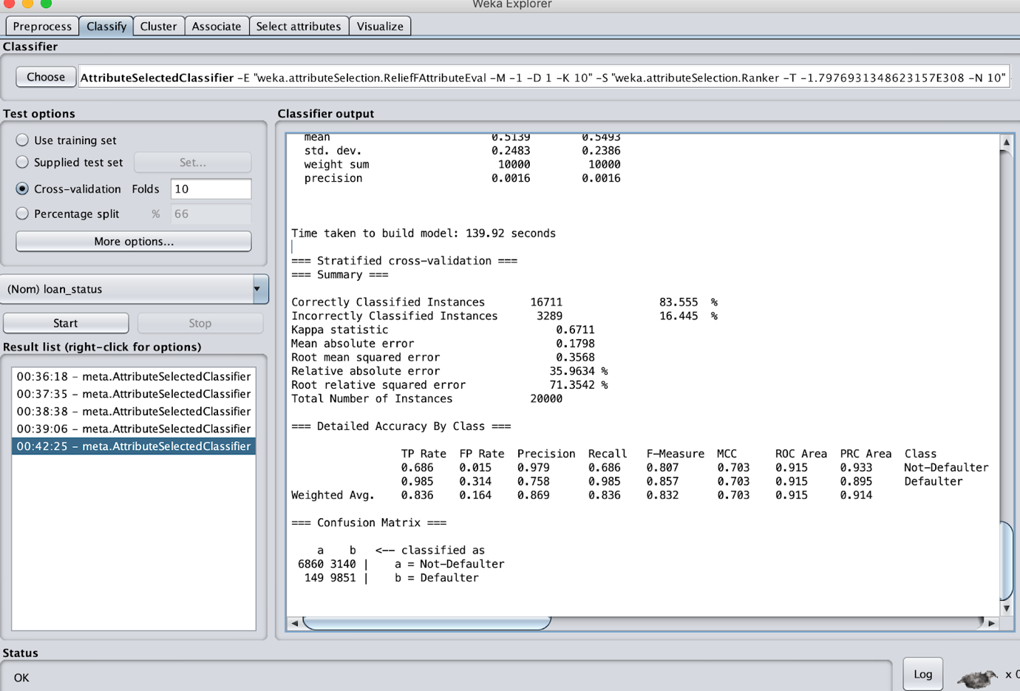

### Using Symmetric Attribute Evaluation

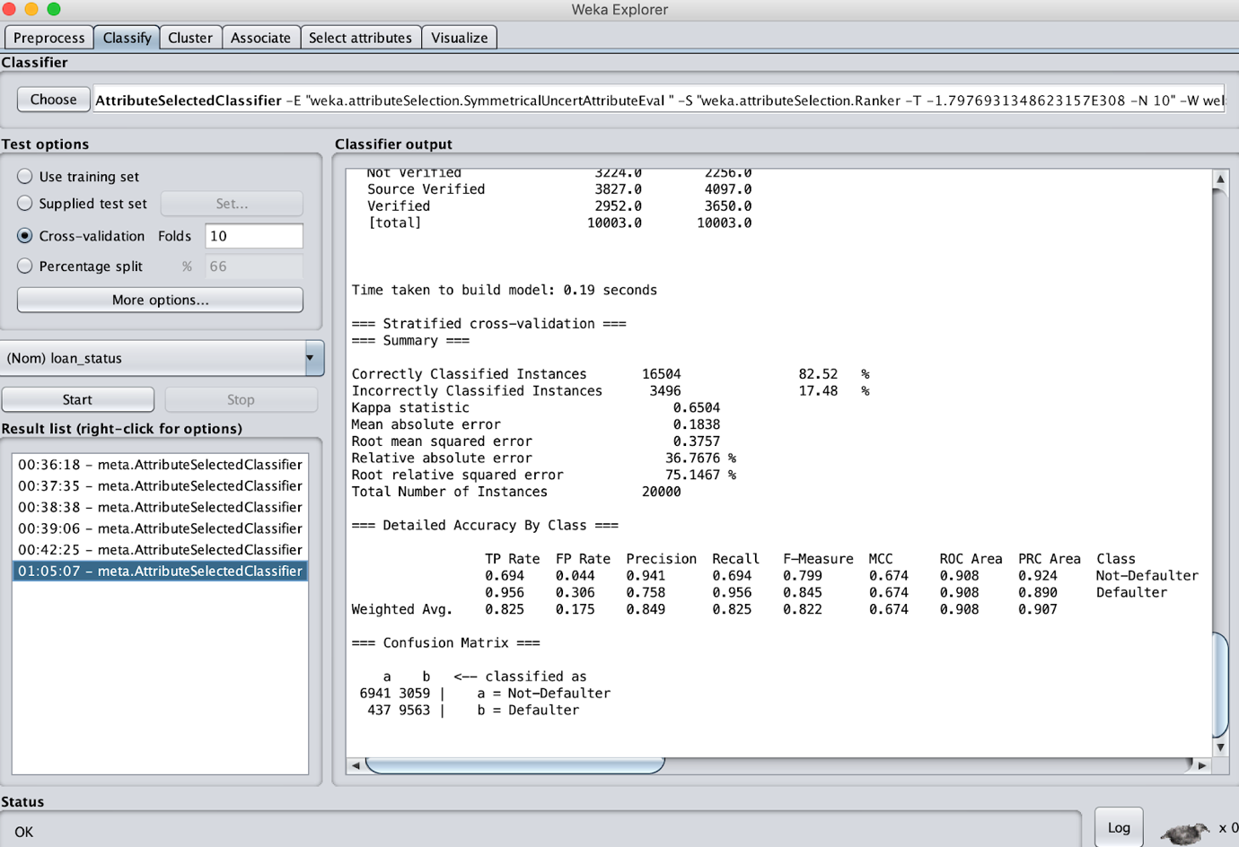

|  |  |  |  |  |  |
| --- | --- | --- | --- | --- | --- |
| Attribute Selection Algorithm | Correctly Classified Instances | Precision | F-measure | ROC Area | RMS Error |
|  |  |  |  |  |  |
| Correlation | 82.465% | 0.848 | 0.822 | 0.908 | 0.375 |
| Gain Ratio | 82.385% | 0.848 | 0.821 | 0.907 | 0.3779 |
| InfoGain | 82.66% | 0.852 | 0.823 | 0.909 | 0.3728 |
| ReliefF Attribute | 83.555% | 0.869 | 0.832 | 0.915 | 0.3568 |
| OneR | 83.685% | 0.864 | 0.834 | 0.916 | 0.3532 |
| SymmetricUncert | 82.52% | 0.849 | 0.822 | 0.908 | 0.3757 |

The best model based on ROC is OneR with 0.9160.

## J48 Algorithm

Decision Tree Algorithm is to find out the way the attributes-vector behaves for a number of instances. Also, on the bases of the training instances the classes for the newly generated instances are being found. This algorithm generates the rules for the prediction of the target variable. With the help of tree classification algorithm, the critical distribution of the data is easily understandable. J48 is an extension of ID3. The additional features of J48 are accounting for missing values, decision trees pruning, continuous attribute value ranges, derivation of rules, etc. In the WEKA data mining tool, J48 is an open source Java implementation of the C4.5 algorithm. The WEKA tool provides a number of options associated with tree pruning. In case of potential over fitting pruning can be used as a tool for précising. In other algorithms the classification is performed recursively till every single leaf is pure, that is the classification of the data should be as perfect as possible. This algorithm it generates the rules from which particular identity of that data is generated. The objective is progressively generalization of a decision tree until it gains equilibrium of flexibility and accuracy.

In this case, we have classified the loan borrower’s ability to repay based on Defaulter or Not-Defaulter by designing tree.

### Using Correlation Attribute Evaluation

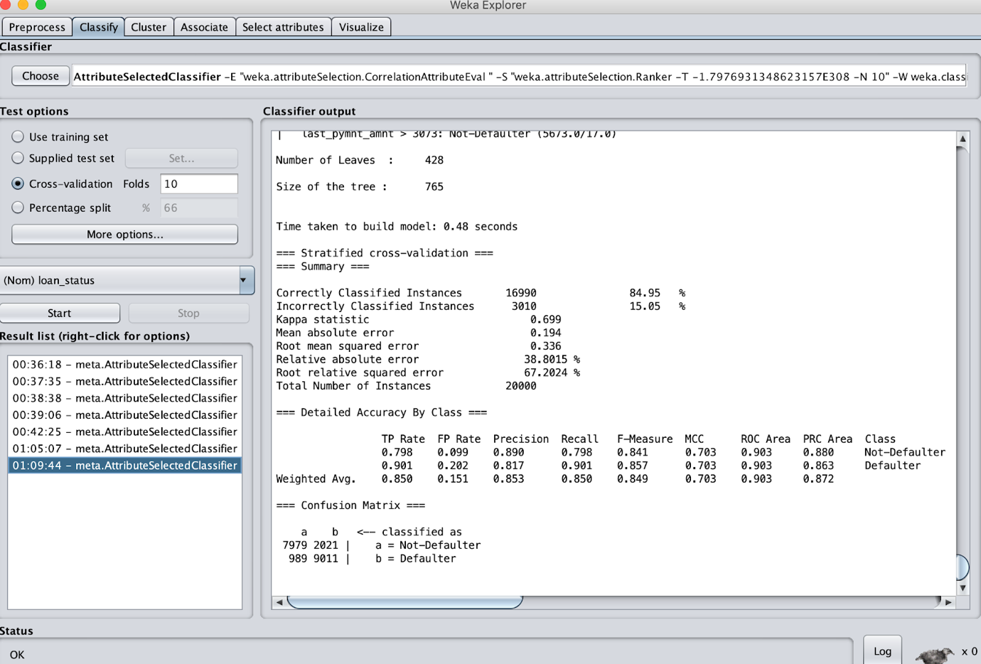

### Using Gain Ratio Attribute Evaluation

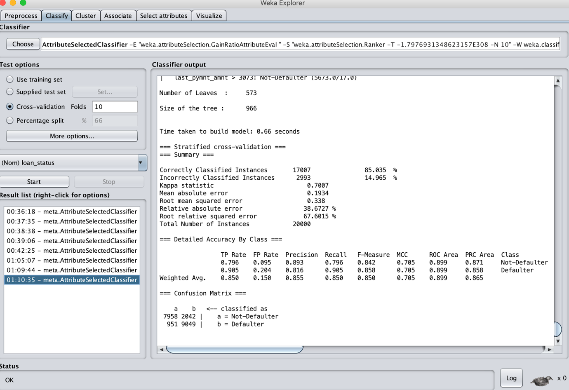

### Using InfoGain Attribute Evaluation

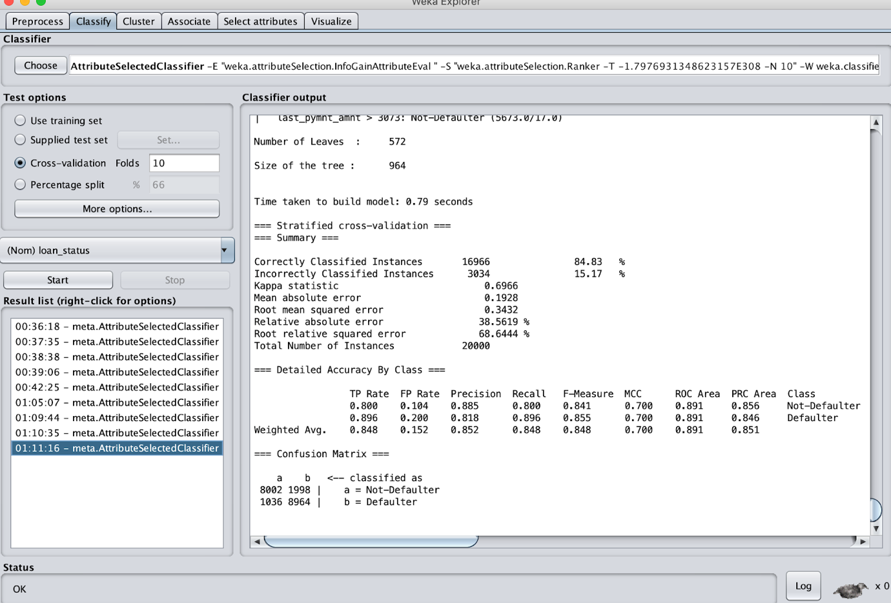

### Using OneR Attribute Evaluation

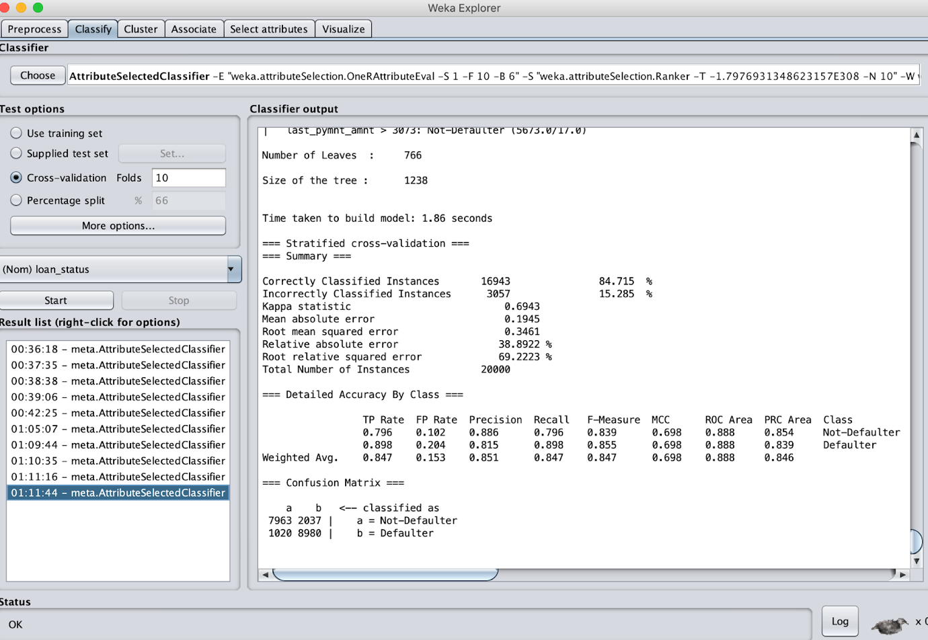

### Using RelieF Attribute Evaluation

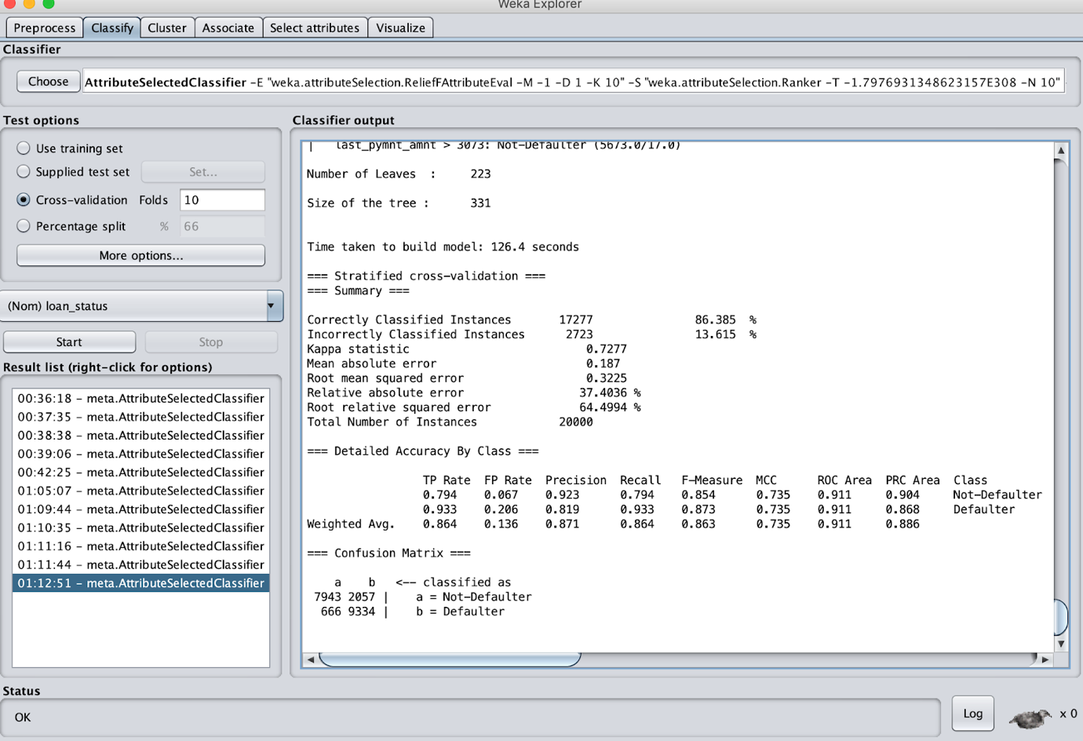

### Using Symmetric Attribute Evaluation

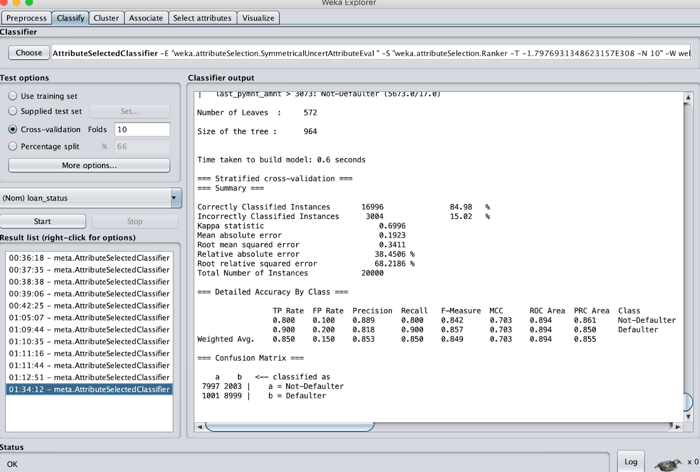

|  |  |  |  |  |  |
| --- | --- | --- | --- | --- | --- |
| Attribute Selection Algorithm | Correctly Classified Instances | Precision | F-measure | ROC Area | RMS Error |
|  |  |  |  |  |  |
| Correlation | 84.95% | 0.853 | 0.849 | 0.903 | 0.336 |
| Gain Ratio | 85.035% | 0.855 | 0.850 | 0.899 | 0.338 |
| InfoGain | 84.83% | 0.852 | 0.848 | 0.891 | 0.3432 |
| ReliefF Attribute | 86.385% | 0.871 | 0.863 | 0.911 | 0.3225 |
| OneR | 84.715% | 0.851 | 0.847 | 0.888 | 0.3461 |
| SymmetricUncert | 84.98% | 0.853 | 0.849 | 0.894 | 0.3411 |

The best model based on ROC is ReliefF with 0.911.

## Random Forest Algorithm

Random forests or random decision forests are an ensemble learning method or classification, regression and other tasks, that operate by constructing a multitude of decision trees at training time and outputting the class that is the mode of the classes (classification) or mean prediction (regression) of the individual trees. Random decision forests correct for decision trees' habit of over fitting to their training set.

Random Forest is established on the fact that forests of trees splitting with oblique hyperplanes can gain accuracy as they grow without suffering from overtraining, as long as the forests are randomly restricted to be sensitive to only selected feature dimensions. Hence Random Forest would be beneficial classifier to classify between the players with large difference in stats by not over fitting it.

### Using Correlation Attribute Evaluation

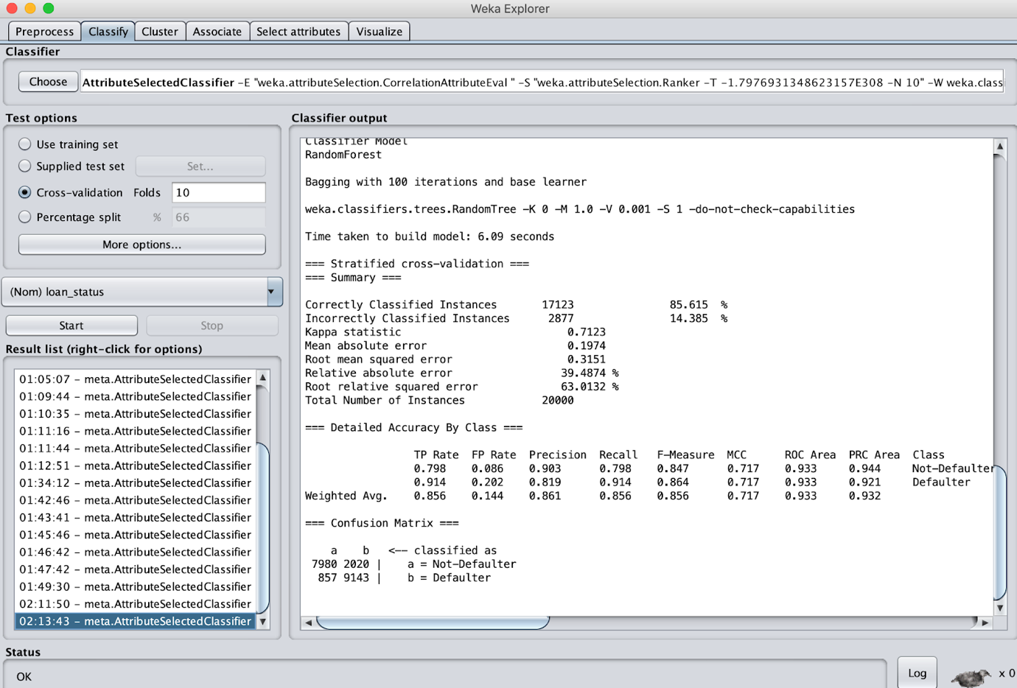

### Using Gain Ratio Attribute Evaluation

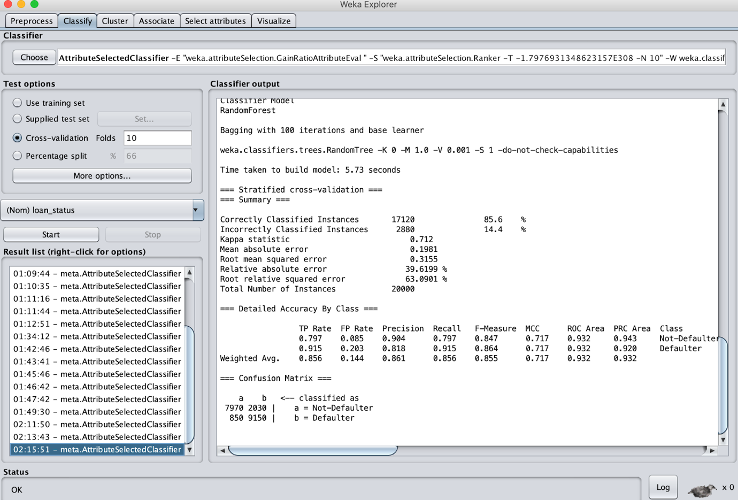

### Using InfoGain Attribute Evaluation

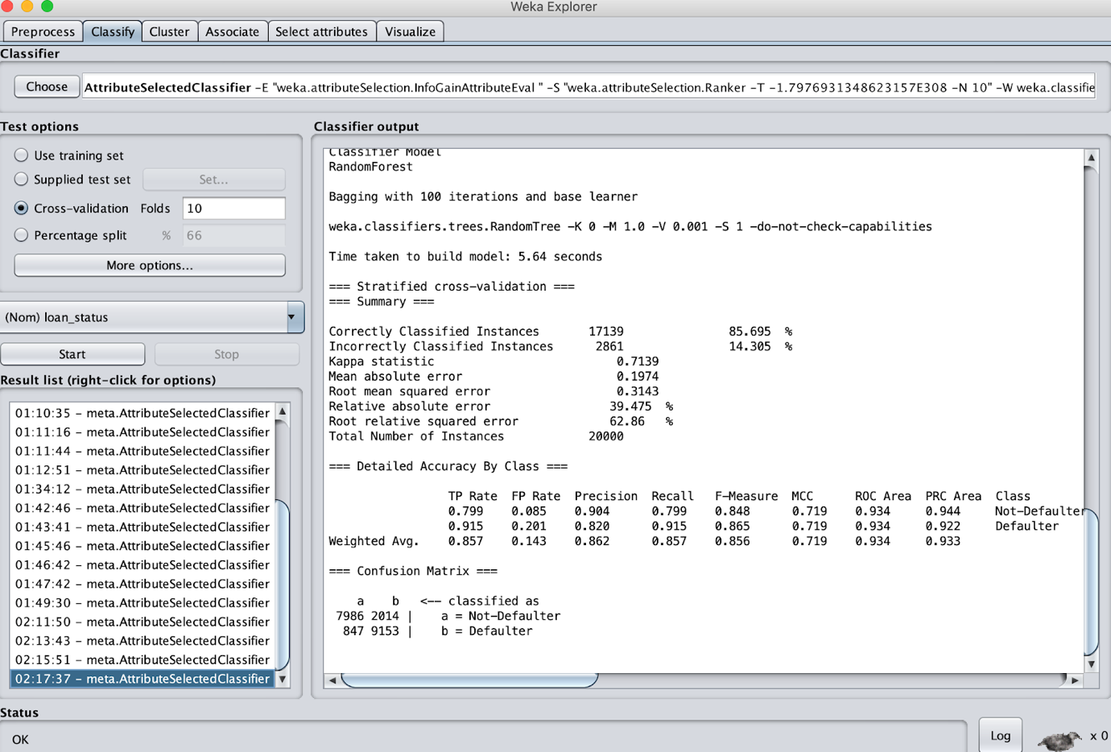

### Using OneR Attribute Evaluation

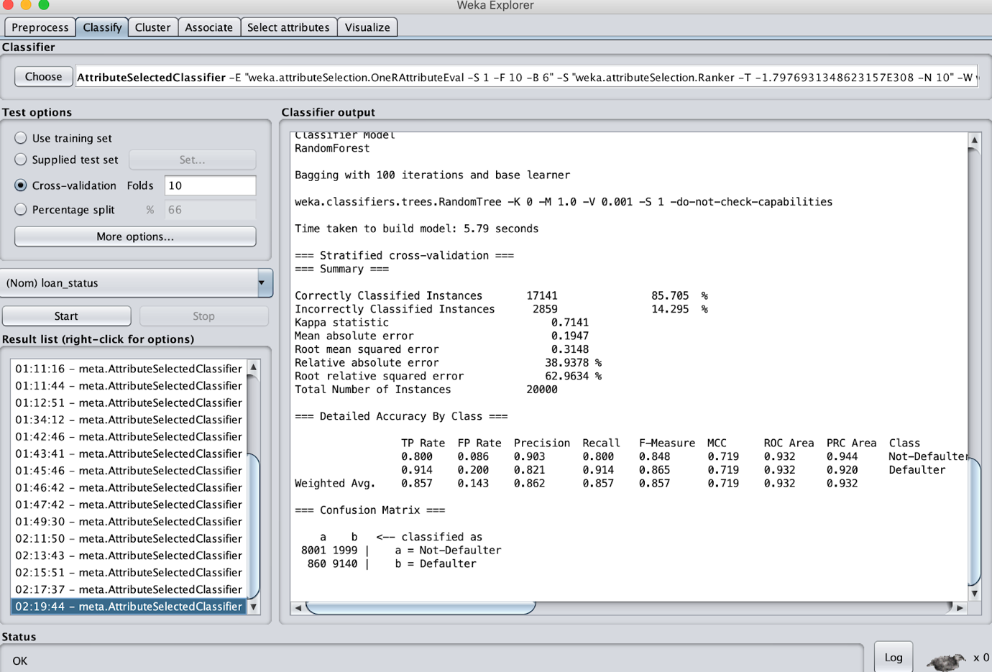

### Using RelieF Attribute Evaluation

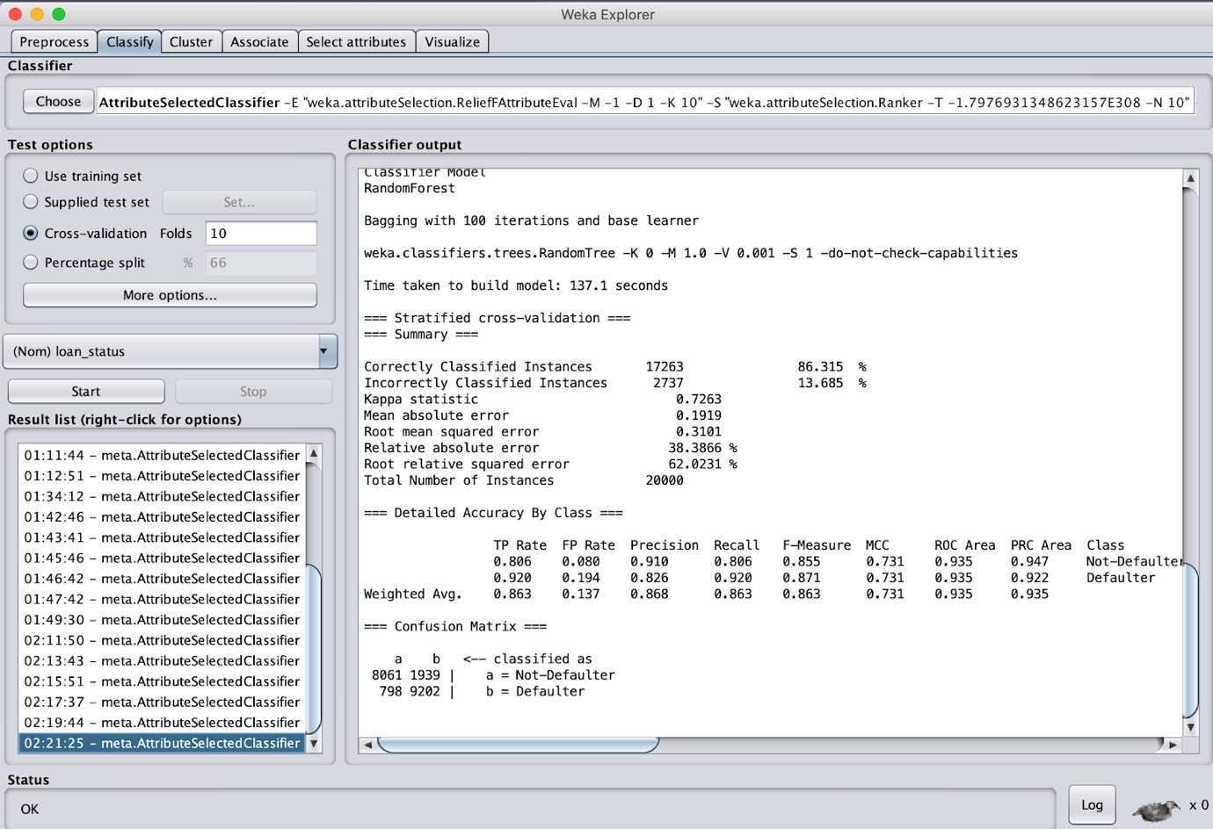

### Using Symmetric Attribute Evaluation

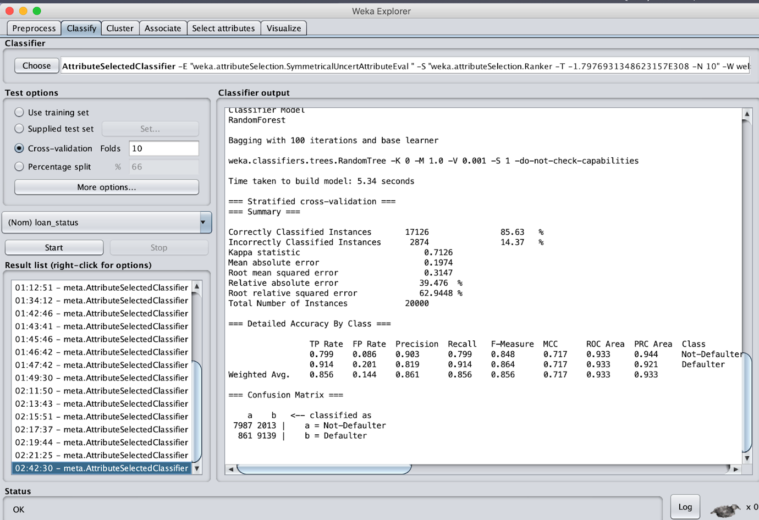

|  |  |  |  |  |  |
| --- | --- | --- | --- | --- | --- |
| Attribute Selection Algorithm | Correctly Classified Instances | Precision | F-measure | ROC Area | RMS Error |
|  |  |  |  |  |  |
| Correlation | 85.615% | 0.861 | 0.856 | 0.933 | 0.3151 |
| Gain Ratio | 85.6% | 0.861 | 0.855 | 0.932 | 0.3155 |
| Info Gain | 85.695% | 0.862 | 0.856 | 0.934 | 0.3143 |
| ReliefF Attribute | 86.315% | 0.868 | 0.863 | 0.935 | 0.3101 |
| OneR | 85.705% | 0.862 | 0.857 | 0.932 | 0.3148 |
| SymmetricUncert | 85.63% | 0.861 | 0.856 | 0.933 | 0.3147 |

In this case, considering the ROC area, ReliefF is better with 0.935.

## Simple Logistic Algorithm

Logistic regression is the appropriate regression analysis to conduct when the dependent variable is dichotomous (binary). Like all regression analyses, the logistic regression is a predictive analysis. Logistic regression is used to describe data and to explain the relationship between one dependent binary variable and one or more nominal, ordinal, interval or ratio-level independent variables.

### Using Correlation Attribute Evaluation

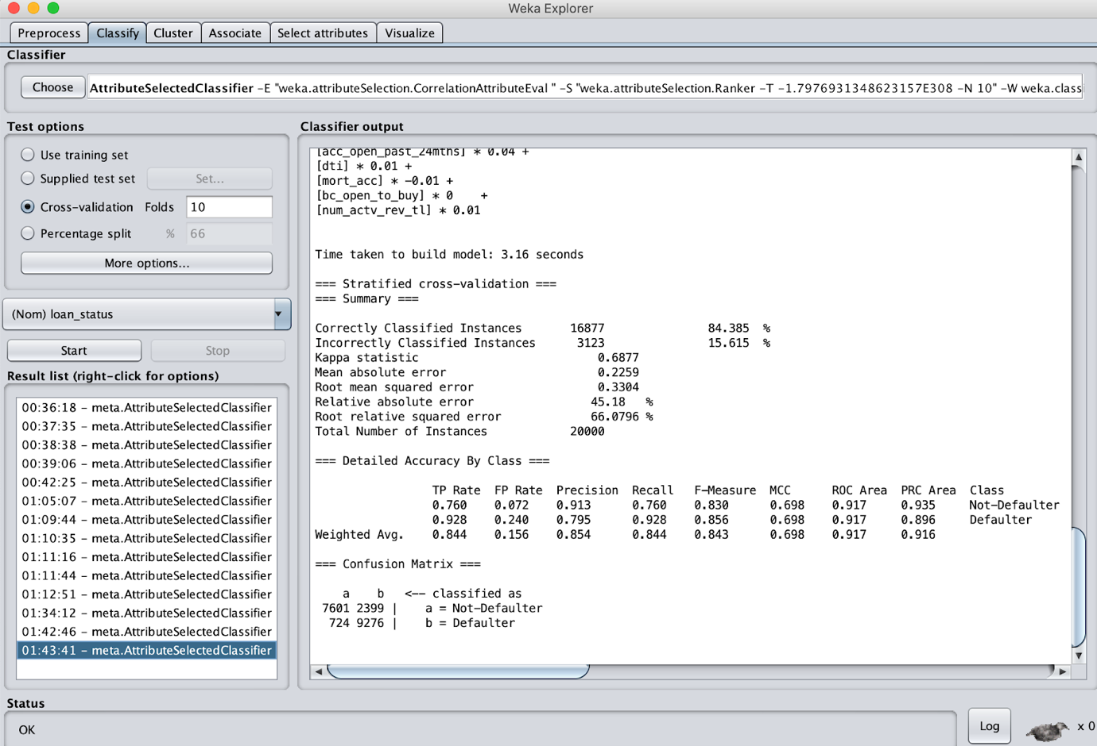

### Using Gain Ratio Attribute Evaluation

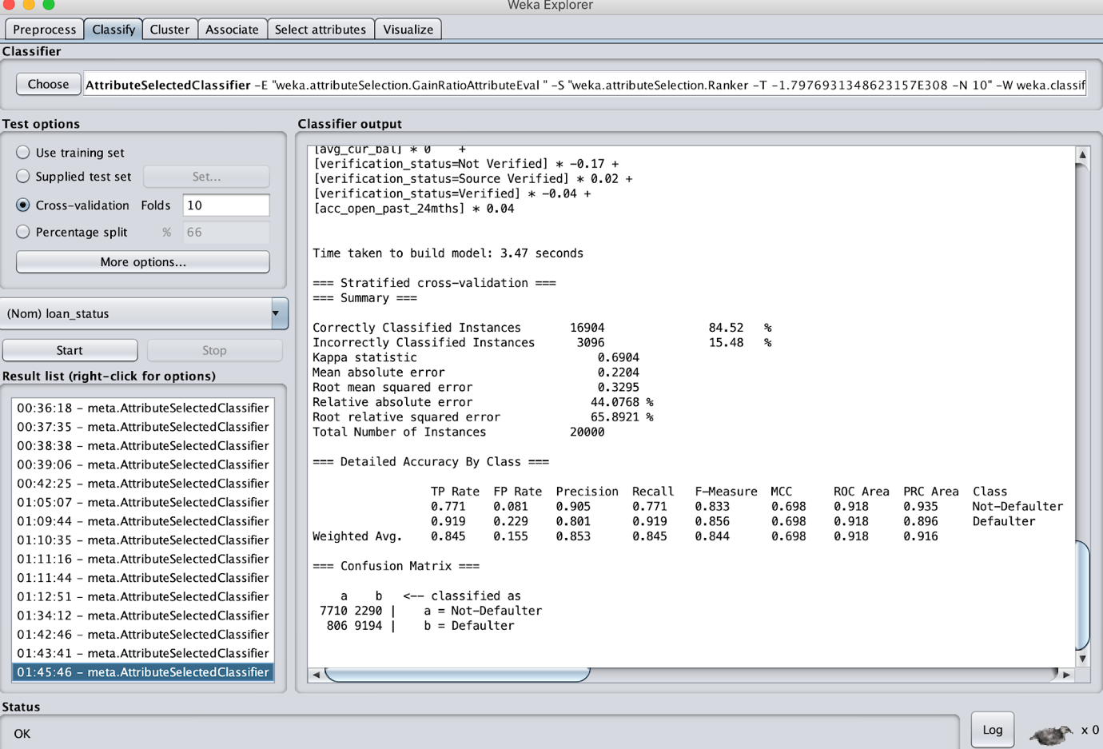

### Using InfoGain Attribute Evaluation

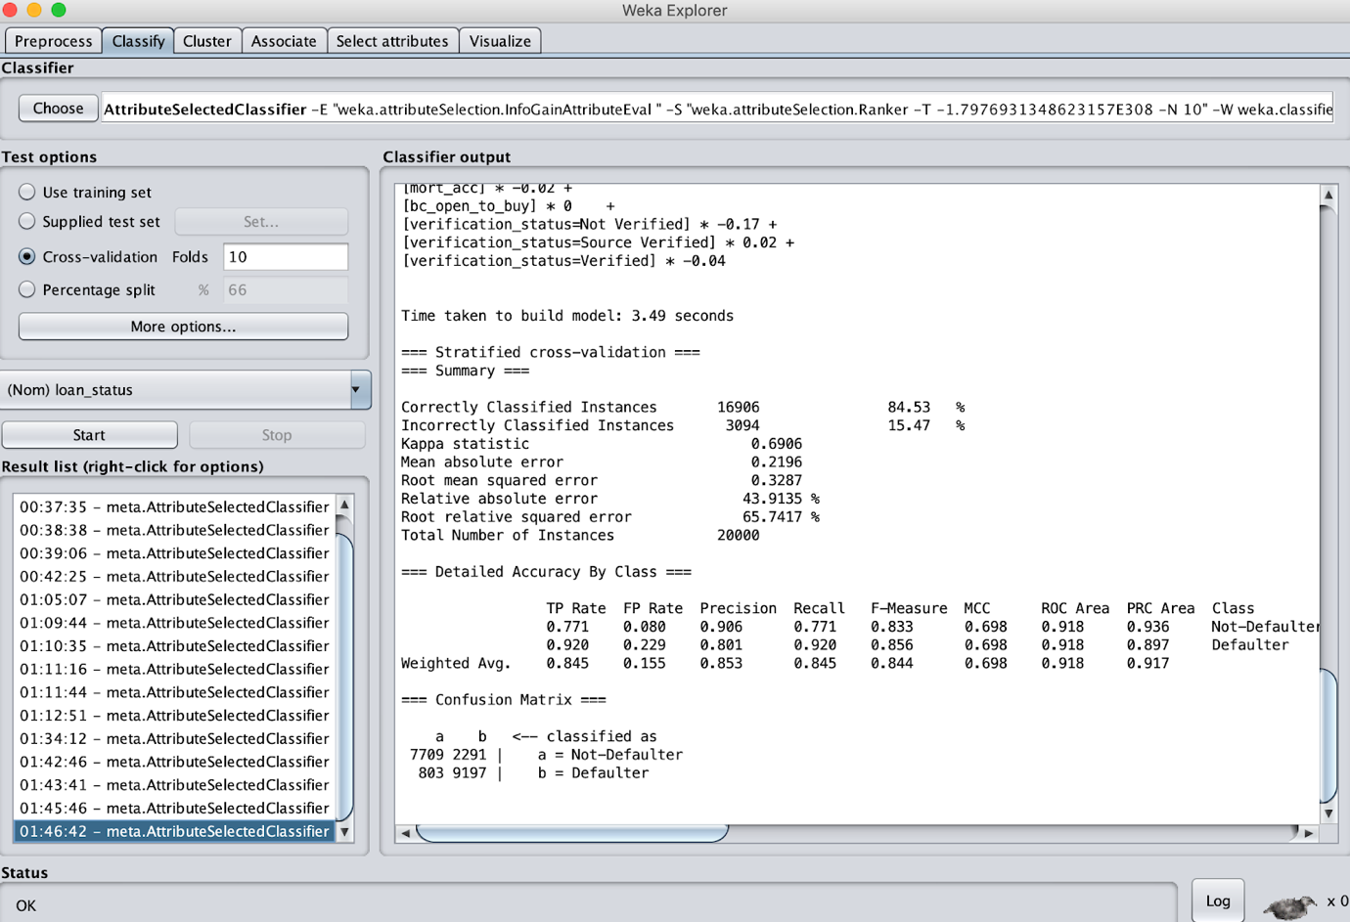

### Using OneR Attribute Evaluation

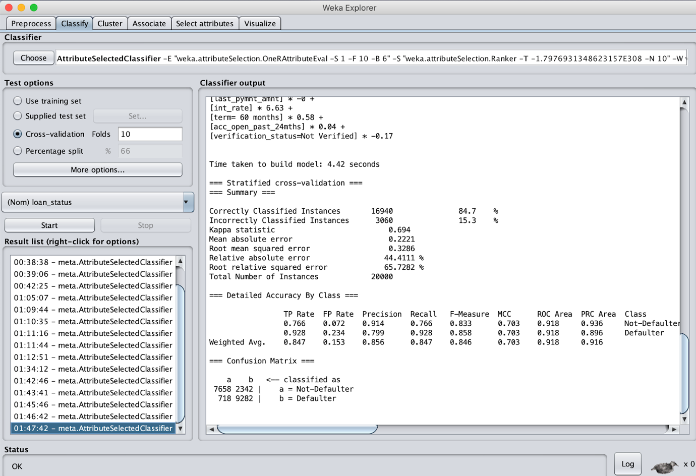

### Using RelieF Attribute Evaluation

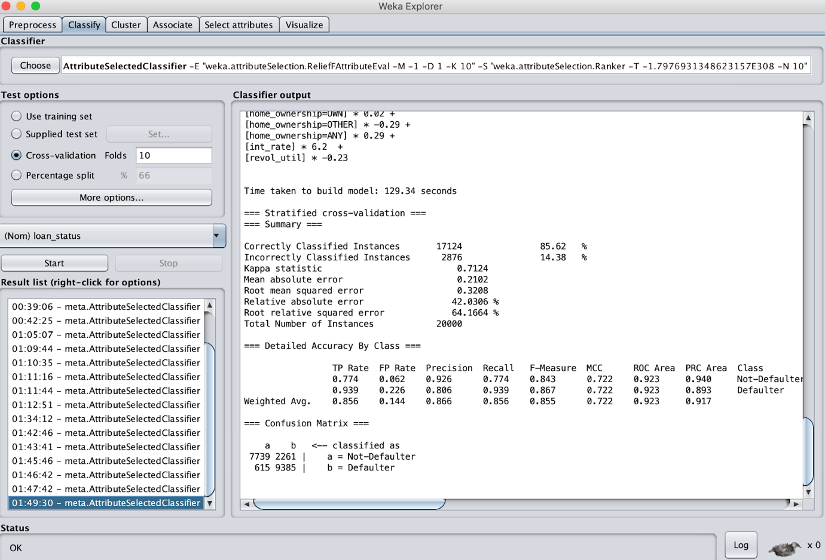

### Using Symmetric Attribute Evaluation

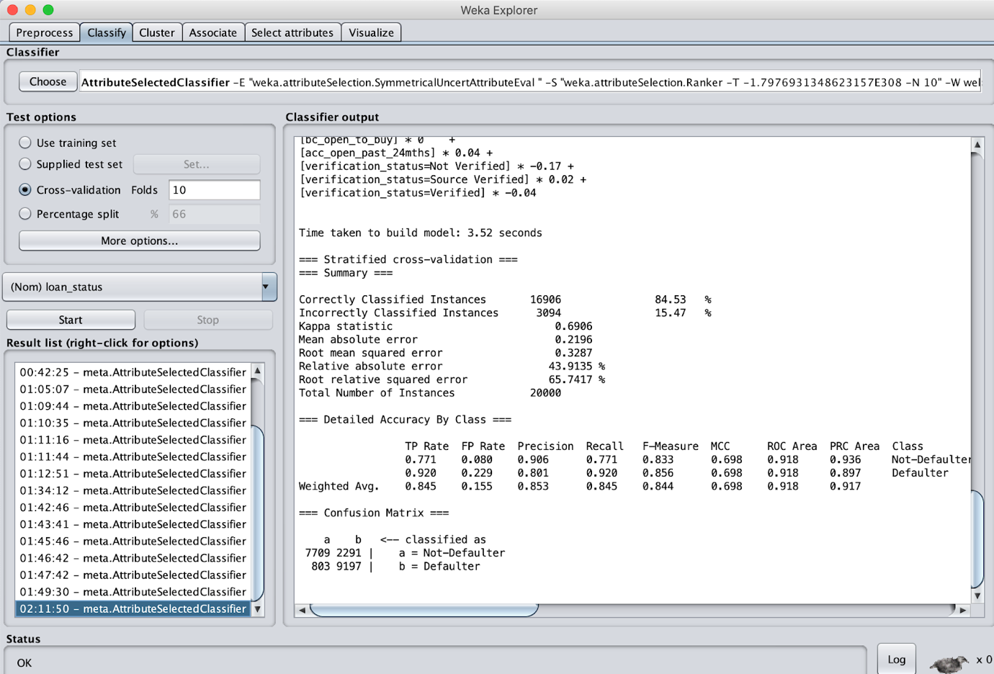

|  |  |  |  |  |  |
| --- | --- | --- | --- | --- | --- |
| Attribute Selection Algorithm | Correctly Classified Instances | Precision | F-measure | ROC Area | RMS Error |
|  |  |  |  |  |  |
| Correlation | 84.385% | 0.854 | 0.698 | 0.917 | 0.3304 |
| Gain Ratio | 84.52% | 0.853 | 0.844 | 0.918 | 0.3295 |
| Info Gain | 84.53% | 0.853 | 0.844 | 0.918 | 0.3287 |
| ReliefF Attribute | 85.62% | 0.866 | 0.855 | 0.923 | 0.3208 |
| OneR | 84.7% | 0.856 | 0.846 | 0.918 | 0.3286 |
| SymmetricUncert | 84.53% | 0.853 | 0.844 | 0.918 | 0.3287 |

In this case, considering the ROC area, ReliefF is better with 0.923.

# Results

After all the preprocessing and deploying the model in WEKA, there were several metrics evolving across the 20 models. The major metrics that should be taken into consideration are ROC area, Precision and Root mean square error.

But considering ROC area as a parameter to select the best model, Random Forest Algorithm with ReliefF Attribute gives the highest ROC area (0.935). The other models weren’t compared based on the class accuracy because sometimes there may be a case where the class is biased, or the TP rate may not have been accurate.

# Conclusions

In this project, we have developed a model to predict if a loan borrower will repay the loan based on the data provided by Lending Club. After building model, data analysis and testing, we made the following conclusions:

The models are not entirely perfect though we are getting an accuracy of around 85%. It is good that investors can decide the percentage of the new loans that they want to finance. The classification accuracy is a very problematic measure for imbalanced classification which is very common in investment and banking sector and can lead us to make wrong decisions. In situations like this, the better measure is the ROC-curve which shows the true positive rates against false positive rates. We have further improved the model by having stratified sampling.

There was a total of 20 models that were computed finally. Examining the best performance for the four techniques by comparative the accuracy and ROC area using the dataset after applying Attribute Selection, it was evident that learning procedure is performing better with Random Forest model in terms of higher accuracy rate and high ROC area.

# Work Distribution

The project was divided into 4 phases:

1. Data Pre-Processing
2. Model building
3. Testing the models
4. Documentation

The data clubbing and integration was done by Vijay. Santosh and Vijay had further used that data for preprocessing using various JMP Pro features. During the planning phase project there were several discussions on which models to be used that could contribute towards a better model.

So, we split for 10 days and ran our own set of combinations that we felt was right. After the stipulated time, we met back and then compared our findings and choose the best among the two.

We distributed the load equally while building the model and ran all the 20 combinations took screenshots and integrated our findings. We then validated the results and then went for documentation.

The documentation load was shared between Santosh and Vijay. Santosh created the templates and the initial outline; Vijay added the necessary information required to understand the concepts. Results, Conclusions were written together by both Santosh and Vijay.

# Learnings

This Data mining project coupled with our knowledge on supervised learning has given us insight into how we can use the data with both machine learning and data mining for various tasks. We learned a great deal about data preprocessing and model building.

Also, we learnt a lot about the JMP Pro tool in the process of data cleaning and pre-processing. We also tried out exploring *Predictive screening, fitting models, analyzing correlation, writing JSL scripts, feature distribution, sampling, model building and evaluation etc.* features from JMP. We also built models in JMP with other classification algorithms as well.

We learned that raw data is bad to start building models on and we need to process the data according to our goals. We learnt a lot about what features are and how would they be a part for a good model.

This project has enabled us to work in some data science projects henceforth. There were several challenges that we faced during the project building.

1. The preprocessing of data across various factors that was to be accounted for.
2. Understanding the essence of Data Mining implementation in real life scenarios.
3. Compare performance of models based on accuracy, precision, ROC area etc.
4. Understanding the data mining algorithms and their use in different kinds of dataset.

# References

1. Naïve Bayes: Devin Soni, “Introduction to Naïve Bayes Classification” <https://towardsdatascience.com/introduction-to-naive-bayes-classification-4cffabb1ae54>
2. J48: Gaganjot Kaur, “Improved J48 Classification Algorithm for the Prediction of Diabetes”, <http://citeseerx.ist.psu.edu/viewdoc/download?doi=10.1.1.678.9273&rep=rep1&type=pdf>
3. Random Forest: Standard Random Forest Definition <https://en.wikipedia.org/wiki/Random_forest>
4. Random Forest: Sushilkumar Rameshpant Kalmegh,” Comparative Analysis of WEKA Data Mining Algorithm RandomForest, RandomTree and LADTree for Classification of Indigenous News Data <https://pdfs.semanticscholar.org/d334/ec05c5bafed96ff40bb6ca219253e0f7040d.pdf>
5. <https://www.jmp.com/support/help/14-2/predictor-screening.shtml>
6. <https://www.statisticssolutions.com/what-is-logistic-regression/>
7. <http://www.biostathandbook.com/simplelogistic.html>